cGMP Plant Project
cGMP制剂厂项目
南京佳顿自动化设备有限公司 专业生产配液罐，提取罐，储罐等压力容器和管道工程建设的生产与销售。公司网站www.gaeyj.com
CONTRACTOR
Prepared By起稿
Reviewed By检查
Approved By审核
NAME姓名
DESIGNATION职位
Validation Engineer
Validation Manager
Project Manager
SIGNATURE签名
DATE日期
OWNER
NAME姓名
DESIGNATION职位
SIGNATURE签名
DATE日期
Reviewed By检查
Approved By审核
Version History
历史版本
VERSION
DESCRIPTION
WRITTEN BY
VERSION DATE
版本
描述
作者
版本日期
Contents
目录
1
Introduction 简介 .......................................................................................................................................... 6
Purpose 目的 ................................................................................................................................................. 6
Scope 范围 .................................................................................................................................................... 6
Abbreviation 缩写 ......................................................................................................................................... 8
Site Description 工厂描述 ............................................................................................................................. 9
Responsibilities职责 ....................................................................................................................................10
Validation Committee 验证委员会 ...........................................................................................................10
XX Validation Team XX验证团队 ............................................................................................................11
业主 Validation Team 业主验证团队 .......................................................................................................11
Supplier Support Team 供应商支持团队 ..................................................................................................12
Third Part Support Team 第三方支持团队 ...............................................................................................13
Validation strategy 验证策略 .......................................................................................................................13
General Principle 基本原理 ......................................................................................................................13
Validation Sequence 验证顺序 .................................................................................................................15
Deviation 偏差 ..........................................................................................................................................15
Re-Validation 再验证 ................................................................................................................................15
Documentation 文件 ................................................................................................................................15
General 通用 .........................................................................................................................................15
Numbering Procedure 编号程序 ...........................................................................................................17
Document Content 文件内容 ................................................................................................................19
VALIDATION MATRIX 验证表 .......................................................................................................................19
Validation Activities 验证活动 .....................................................................................................................19
User Requirement Specification (URS) 用户需求说明 ..............................................................................19
General 概论 .........................................................................................................................................19
Document preparation 文件准备..........................................................................................................20
Functional Requirement Specification (FRS) 功能需求说明 ......................................................................21
2
3
4
5
6
6.1
6.2
6.3
6.4
6.5
7
7.1
7.2
7.3
7.4
7.5
7.5.1
7.5.2
7.5.3
8
9
9.1
9.1.1
9.1.2
9.2

9.3
System Impact Assessment (SIA) 系统影响评估 .......................................................................................22
Supplier Audit 供应商审计 .......................................................................................................................22
Design Qualification (DQ) 设计确认 .........................................................................................................22
General 概要 .........................................................................................................................................23
Document preparation 文件准备..........................................................................................................23
Risk Analysis (RA) 风险分析 .....................................................................................................................24
General 概要 .........................................................................................................................................24
Document preparation 文件准备..........................................................................................................24
Execution 执行 ......................................................................................................................................25
Calibration 校准........................................................................................................................................25
FAT/SAT ....................................................................................................................................................25
General 概要 .........................................................................................................................................25
Document preparation 文件准备..........................................................................................................26
Commissioning 调试 .................................................................................................................................27
Installation Qualification (IQ) 安装确认 ...................................................................................................27
Document Preparation文件准备 .........................................................................................................27
Execution 执行 ......................................................................................................................................29
Acceptance Criteria 可接受标准 ...........................................................................................................29
Operational Qualification (OQ) 运行确认 .................................................................................................30
Document Preparation 文件准备..........................................................................................................30
Pre-Qualification Requirement 预确认要求 .........................................................................................31
OQ Approach 运行确认方法 .................................................................................................................31
OQ Execution 运行确认执行 ................................................................................................................32
Acceptance Criteria 可接受标准 ...........................................................................................................32
Performance Qualification (PQ) 性能确认 ................................................................................................33
Document Preparation 文件准备..........................................................................................................33
Pre-Qualification Requirement 预确认要求 .........................................................................................34
PQ Approach PQ方法 ...........................................................................................................................35
9.4
9.5
9.5.1
9.5.2
9.6
9.6.1
9.6.2
9.6.3
9.7
9.8
9.8.1
9.8.2
9.9
9.10
9.10.1
9.10.2
9.10.3
9.11
9.11.1
9.11.2
9.11.3
9.11.4
9.11.5
9.12
9.12.1
9.12.2
9.12.3

9.12.4
9.12.5
9.13
9.13.1
9.13.2
9.13.3
9.13.4
9.13.5
9.14
9.15
9.16
10
PQ Execution PQ执行...........................................................................................................................35
Acceptance Criteria 可接受标准 ...........................................................................................................36
Process Validation (PV) 工艺验证 .............................................................................................................36
Document Preparation 文件准备..........................................................................................................37
Pre-Validation Requirement 预验证要求 ..............................................................................................38
Validation Approach 验证方法 .............................................................................................................39
Validation Execution 验证执行 .............................................................................................................39
Acceptance Criteria 可接受标准 ...........................................................................................................41
Cleaning Validation (CV) 清洗验证 ...........................................................................................................41
Analytical Method Validation (MV) 分析方法验证 ...................................................................................42
Automation / Computer System Validation 自动控制/计算机系统验证 ..................................................42
Change Control 变更控制 .........................................................................................................................42
Training 培训 ............................................................................................................................................43
Maintaining the Validated State 维持验证状态 .......................................................................................43
Validation Plan 验证计划 .........................................................................................................................43
Project Validation Plan 项目验证计划 ......................................................................................................43
Routine Validation Plan 常规验证计划 ....................................................................................................44
Appendix List附件列表 ............................................................................................................................45
11
12
13
13.1
13.2
14

1
Introduction 简介
This Validation Master Plan (VMP) describes the philosophy and approach to qualification /
validation: utilities, manufacturing equipment and processes, process control systems and
laboratory equipment and test methods. It is a guide, establishing the limits, strategies and
action plans to be developed and implemented in the qualification / validation activities to
assure the quality and integrity of products for XXXX site.
本验证主计划描述了公共系统、生产设备、生产工艺、工艺控制系统、实验室设备、检测方法的
确认/验证的原理和方法。它是一个指南，在确认/验证活动中建立限度、策略和实施计划，从而
保证 XXX工厂中产品的质量和完整性。
This document will be reviewed periodically and updated when necessary to reflect completed
activities or newly identified qualification / validation activities that need to be included in the
schedule.
本文件应定期审核，并在必要是升级版本，如：完成活动，或有新经认定需要添加进进度表的确
认/验证活动时。
All related regulatory of US. FDA, ICH and China SFDA should be well considered when
perform qualification / validation.
所有的美国 FDA, ICH和中国 SFDA 相关的法规都应在确认/验证中充分考虑。
2
Purpose 目的
The purpose of the Validation Master Plan is intended to:
验证主计划的目的有：
•
Outline the principle and approach in relation to qualification / validation related activities
throughout the XXX site.
概述 XXX工厂中确认/验证相关活动的原则和方法。
•
Describe the validation schedule and plan for each product quality impact system.
描述对产品质量有影响系统的验证进度表和计划。
Following approval of this Validation Master Plan, the personnel, who signed off this document,
agree with the concept of qualification / validation and will provide all necessary resources to
meet the qualification / validation schedule and requirements.
同意这份验证总计划并签字批准的相关人员同意确认/验证理念，并为满足验证进度和要求提供
所有必要的资源。
3
Scope 范围
Validation Master Plan covers all the necessary qualification / validation activities to be carried
out for XXX site.
本验证主计划覆盖了发生在 XXX工厂中所有必要的确认/验证活动。

The qualification / validation activities include the following:
确认/验证活动包括以下：
•
•
•
•
•
HVAC system and environmental room
HVAC系统和房间
Manufacturing process equipment
生产工艺设备
Utilities
公共系统
Process control system/automation systems
工艺控制系统/自动系统
Laboratory equipment
实验室设备
Computer systems are categorized in two subsets according to their equipment dependence
properties:
计算机系统将按照其设备独立性分成两类：
•
Process control/automation systems which are more tightly integrated with equipment.
与设备紧密结合的工艺控制/自动系统
•
Information system that primarily encompasses management related systems, which
defined in Computer System Lifecycle.
综合管理相关系统的信息系统，需定义计算机系统生命周期。
Validation on Type 1 computer system, process control/automation system, is covered by this
VMP. However validation on Type 2 computer system and interface between systems will be
cover by another separate Computer System Validation protocol.
第一类计算机系统，工艺控制/自动系统，的验证包含在本验证主计划中。但第二类计算机系统
和系统间的交接将会包括在其他单独的计算机系统验证方案中。
Cleaning performance of certain equipment with CIP function or certain dedicated CIP
equipment is an integral function of that equipment. Cleaning validation on such equipment or
systems, from operation qualification perspective, is covered by this VMP. However detailed
cleaning validation, from overall process performance perspective, is to be elaborated in extra
Cleaning Validation Protocol.
某些设备的在线清洁功能或某些专属在线清洁设备的清洁性能将整合在该设备的功能中。这些设
备或系统的清洁验证，从运行确认的角度，是属于本验证主计划的范围。但详细的清洁验证，从
整体工艺性能的角度，应在单独的清洁验证方案中精确描述。
Moreover Analytical Method Validation Plan may be developed separately as project expands.
The general description of these activities refers to Section 9 of this VMP.

此外分析方法验证计划将作为项目的延伸单独制作。这些活动的简要描述请见本验证主计划的第
九部分。
4
Abbreviation 缩写
Critical Process Parameter
CPP
关键工艺参数
Cleaning Validation
CV
清洁验证
Design Qualification
DQ
设计确认
Environment Management System
EMS
环境管理系统
Factory Acceptance Test
FAT
工厂接受测试
Functional Requirement Specification
FRS
功能要求说明
Good Automated Manufacturing Practice
GAMP
自动生产管理规范
Good Engineering Practice
GEP
工程管理规范
Good Manufacturing Practice
GMP
生产质量管理规范
Installation Qualification
IQ
安装确认
Method Validation
MV
方法验证
Operational Qualification
OQ
运行确认
Performance Qualification
PQ
性能确认

Risk Analysis
RA
风险分析
Site Acceptance Test
SAT
现场接受测试
Standard Operational Procedure
SOP
URS
标准操作规程
User Requirement Specification
用户要求说明
Validation Master Plan
VMP
验证主计划
Waste Water Treatment Plant
WWTP
废水处理设施
5
Site Description 工厂描述
XXX are building a greenfield manufacturing facility with XX acres (XX Hectares) in the
outskirts of XXX Province of the People Republic of China. The facility will manufacture both
tablets and capsules for sale to the international marketplace.
XXX将在 XXX市郊，新建一个总面积 XX亩（XX公顷）的制剂厂。工厂将生产面向国际市场
的片剂和胶囊剂产品。
The facility is a multi-purpose plant that will manufacture different products with multi-purpose
equipment.
工厂配备多用途设备用于多种不同产品的生产。
The buildings, facilities, equipment, and systems associated with the project will be designed
and installed to comply with US Federal, European, and Chinese codes, as well as published
standards and guidelines from public organizations and standards committees.
与项目相关的建筑，设施，设备和系统，其设计与安装必须与美国联邦，欧洲及中国的法规，以
及公共组织和标准委员会已出版的标准和指南相符合。
The facility architectural layout incorporates an integrated design that satisfies the project and
cGMP requirements, specifications, and addresses identified risk assessment factors, while
providing good levels of access for operation, maintenance, personnel, product, component,
and raw material movements.
具有完整设计的厂房设施布局，需满足项目和 cGMP的要求，规格，并体现确定的风险评估因
素，同时为操作，维护，员工，生产，部件和原料转移提供良好的通道。

The facility will be segregated to protect the product from contamination for manufacturer of
solid dosage form. The facility design incorporates the necessary environmental cleanliness in
order to minimize the risks of dust contamination of the product(s) and materials being
handled.
为了在生产口服产品时保护产品，防止污染，本厂房采用分隔厂房。其设计结合了环境洁净的需
求，最大程度降低操作时产品和物料受粉尘污染的风险。
The facility is designed with two: CNC and Class D, and one none clean zone. The CNC is
defined as Controlled but not Classified pharmaceutical area. This zone covers the secondary
packaging area and CNC plant corridor. Grade D Gowning area, Production area and Primary
Packaging area are classified as the Grade D area. The admin area, Warehouse and all
technical areas and utility buildings are belonged to none clean area.
厂房设计为两类洁净区 CNC和 D级生产区和一类非洁净区。CNC指控制但无级别生产区。该
生产区包括：二次包装区和工厂走廊。D级区包括 D级更衣室，生产区和内包装区。行政办公
区, 仓库和机房，公用设施区属于非洁净区。
The manufacturing areas will be designed for the commercial manufacturing of solid dosage
products. The facility will be designed according to the requirements of current Good
Manufacturing Practice (cGMP) for manufacturing, processing, packing, or holding of
pharmaceutical products based upon 21 CFR Parts 210 and 211.
生产区为商业化生产口服产品设计。厂房设计符合美国联邦法规 21卷 210部分和 211部分现
行药品生产质量管理规范（cGMP）对药品生产，工艺，包装或贮存的规范化要求。
This VMP are focusing on phase one of this project of a XXXXX Sq.m production facility
这份验证主计划注重于第一阶段一座 XXXXX平方米生产厂房。
6
Responsibilities职责
6.1
Validation Committee
验证委员会
Qualification & Validation will be led by Validation committee. Validation committee should be
composed of XX validation team members and XX validation team members, and agreed by
both parties.
确认和验证由验证委员会领导，验证委员会应由 XX验证团队管理人员及 XX验证团队的管理人
员组成，并经双方认可。
•
Lead the overall work of the validation activities.
领导验证活动的整体工作。
•
Final decision in case of conflict.
进行问题的最终决策。

•
Ensure competent support for qualification,coordinate qualification activities and
scheduling.
有效支持确认工作，安排进度并协调确认活动。
6.2
XX Validation Team
XX验证团队
•
•
•
•
•
Prepare and review the VMP
准备并审核验证主计划
Execute the Design Review.
进行设计审核
Review and guide suppliers to complete FAT/SAT plans for Facility and Utility
审核并指导供应商完成厂房和公用系统的 FAT/SAT计划
Supervise FAT/SAT/commissioning activities for Facility and Utility
指导监督厂房和公用系统的 FAT/SAT/调试活动
Manage and supervise the preparation and execution of IQ, and OQ Protocols for Facility
and Utility
管理并监督厂房和公用系统 IQ，OQ方案的准备和执行
•
•
•
Identify training requirements in support of validation for Facility and Utility
确定厂房和公用系统验证相关的培训要求
Prepare interim validation reports (till OQ) for Facility and Utility
准备厂房和公用系统的中期（到 OQ）验证报告
Handle the validation deviation reports and change controls for Facility and Utility
Validation
处理解决在厂房和公用系统验证过程中偏差报告和变更控制
6.3
业主 Validation Team
业主验证团队
•
•
•
Prepare and review and approve URS
起草、审核并批准 URS
Review and approve the VMP
审核并批准验证主计划
Conduct system impact assessments to define the systems and equipment items
requiring validation
执行系统影响评估，定义与验证相关的系统和设备
•
Review and approve system impact assessment reports
审核并批准系统影响评估

•
•
•
•
•
•
•
•
Prepare DQ Protocols and participate in the DQ execution
准备 DQ 方案并参与 DQ执行
Review and guide suppliers to complete FAT/SAT plans for Process Equipment
审核并指导供应商完成工艺设备的 FAT/SAT计划
Supervise FAT/SAT/commissioning activities for Process Equipment
指导监督工艺设备的 FAT/SAT/调试活动
Approve reports of FAT and SAT
批准 FAT 和 SAT 报告
Prepare and execute IQ/OQ protocols for Process Equipment
准备并执行工艺设备的 IQ/OQ 方案
Review and approve IQ/OQ protocols and reports
审核并批准 IQ/OQ 方案和报告
Prepare and approve the PQ Protocol and execute the PQ
准备和批准 PQ 方案并执行
Review and approve validation deviation reports and change controls
审核并批准验证偏差报告和变更控制
6.4
Supplier Support Team
供应商支持团队
Suppliers will be responsible for qualification / validation related activities as defined in
contract, the scope will include FAT, SAT, Commissioning, DQ, IQ, and OQ.
供应商基于合同，对确认/验证相关活动提供支持，包括：FAT，SAT，调试，DQ，IQ，和
OQ。
•
Prepare FAT / SAT / Commissioning protocol in accordance with supplier’s template and
XX documentation requirement
基于供应商的模板和 XX的文件要求，准备 FAT，SAT，调试方案
•
•
•
•
Prepare qualification / validation protocols in accordance with XXXX documentation
根据 XXXX的文件准备确认/验证方案
Execute approved FAT / SAT / Commissioning qualification protocols
执行批准后的 FAT/SAT/调试确认方案
Prepare FAT / SAT / Commissioning qualification report
准备 FAT/SAT/调试确认报告
Participate in project validation coordination meeting
参加项目验证协调会议

•
Complete the project validation activities following the validation schedule
在验证时间要求内完成项目验证活动
6.5
Third Part Support Team
第三方支持团队
Third Part support Team will be responsible for the test in qualification / validation related
activities as defined in contract.
第三方支持团队基于合同，对确认/验证相关活动中的测试提供支持。
•
•
Prepare test protocol in accordance with regulation and XXXX requirement
基于法规和 XXXX的要求，准备测试方案
Execute approved test protocols
执行批准后的测试方案
7
Validation strategy 验证策略
General Principle 基本原理
7.1
•
The validation processes will be conducted in an organized manner. A validation team
will be organized at the beginning of all validation activities.
按有组织的方式执行验证过程。在所有验证活动开始时将组建一个验证团队。
•
All validation activities will be carried out by qualified personnel. GMP experienced
personnel is expected and adequate training plan need to be developed when
necessary.
由有资质的人员来执行所有验证活动，应为熟悉 GMP制造规范的人，如果需要应准备适
当的培训计划。
•
VMP will be created and approved to serve as the guide of validation activities.Chinese
and FDA GMP requirements, XXXX validation related requirements and related local
regulations will be followed when defined in VMP.
创建验证主计划并获批准以指导验证活动。定义验证主计划的过程中，应遵守中国和美国
FDA GMP 要求，XXXX的验证相关要求和相关的当地法规。
•
Risk based methodology are adopted to determine due validation activities and
deliverable documents. For instance, engineering document, such as FAT/SAT
document can serve as the reference document of IQ/OQ/PQ to reduce the duplicate
effort.
采用基于风险的方法确定预期的验证活动和可交付的文件。例如，工程文件如 FAT/SAT
文件可作为 IQ/OQ/PQ 的参考文件以减少重复劳动。
•
All qualification/validation plans must be prepared, reviewed and approved prior to
initiating execution. The executed plan and report will not be approved with any open
deviations or pending items. The executed plans will not be deemed "formally closed out"

until the relevant reports are completed and fully approved. The approval of one stage
qualification/validation permits processing to next stage of qualification/validation. A
combined IOQ / OPQ plan is permitted for simple pieces of equipment. Engineering
activities should be completed before related qualification/validation activities (FAT
should be completed and approved before IQ execution, SAT / commissioning should be
completed and approved before OQ execution).
开始执行之前必须完成所有确认/验证计划的准备，审核以及批准。任何存在未关闭的偏差
或未完成项目的执行计划和报告不能得到批准。直到相关报告完成并完全获得批准之后才
能正式关闭执行计划。一阶段确认/验证得到批准后才允许进行下一阶段的确认/验证。一
些简单设备的 IOQ/OPQ 计划允许合并。应在相关的确认/验证活动之前完成工程活动
（执行 IQ 之前应完成 FAT，执行 OQ 之前应完成 SAT/调试）。
•
•
Approved procedures are to be included or referenced in the validation plan.
验证方案可包含或参考批准的程序。
The boundary of systems must be defined in “system impact assessment”. The same
model of equipment belong to one system should be grouped.
在“系统影响评估”中定义系统界限。属同一系统的相同型号设备可合并。
•
•
Key measuring instruments will be previously NIST calibrated before being used in
validation activities.
关键测量仪表应在被用于验证活动之前提前按 NIST校准。
Test methods used in validation activities will be validated methods derived from the
appropriate sanctioning bodies (USP, NF etc) or will have been part of a tech transfer
package in compliance with XXXX business and quality standards.
验证活动中使用的测试方法应是源于官方主管机构（美国药典/国家处方集等）的验证过的
方法，或者根据 XXXX的业务和质量标准已作技术转移的方法。
•
•
The data entry on the validation/qualification report will meet the requirements of Good
Documentation Practice.
验证/确认报告中的数据录入满足优良文件规范的要求。
•
Acceptance Criteria established in the validation document will be based on the GMP
regulatory requirements stated in VMP, equipment specification, manufacturer’s
recommendation and XXXX requirement. Acceptance Criteria are an important aspect of
the plan and must be approved and can’t be changed from the time that execution
commences.
验证文件中涉及的可接受标准应根据验证主计划中提及的 GMP 法规要求、设备规格、制
造商的建议和 XXXX的要求制定。可接受标准是计划的重要组成部分，必须在执行前得到
批准并不得在之后进行改动。
•
PQ acceptance criteria may additionally require that the equipment can operate
consistently within a narrower operating range-comparable to those required during

normal working operation and using XXXX materials/samples/raw materials/ finish
products.
性能确认可接受标准可能会额外要求设备使用 XXXX提供的物料/样品/原料/最终产品在一
个较为狭窄的操作范围内持续操作。
7.2
Validation Sequence 验证顺序
A sequential approach will be taken to ensure the successful completion of qualification /
validation. The sequence will follow the “qualification / validation sequence chart” (refer to
Appendix 1 “Qualification / Validation Sequence Chart”) and the detailed description on
document preparation, execution, approach and acceptance criteria of each validation
activities refer to Section 9 of this VMP.
为了成功的完成确认/验证，将会实行一个有特定顺序的方法。该顺序请见“确认/验证顺序图”
（参见附录 1“确认/验证顺序图”），并且每个验证活动的详细的关于文件准备，执行，方法
和接受标准的描述参见本验证主计划的第九部分。
7.3
Deviation 偏差
•
•
During the execution of plans, any deviation from the acceptance criteria will be
addressed in the deviation report and documented in the respective executed report.
在计划的执行过程中，任何背离可接受标准的偏差将在各自的偏差报告中得到记录并在执
行报告中归档。
Deviations should be resolved and approved prior to continuing to the next stage of
validation. If not, an assessment must be given by Quality Unit.
偏差应在继续下一阶段验证前得到解决和批准。否则，质量部门必须给出评估。
7.4
Re-Validation 再验证
Revalidation at XXXX will be defined as changed based. Revalidation shall be monitored
through XXXX change control procedures. System requiring revalidation will be re-tested per
approved protocol. As applicable to the change, either a complete retest of the original
qualification may be required or specific section of the original qualification may be required as
a result of the change. Details of the requirements for retest will be listed on the change
control documentation and action plan will be pre-approved by change control board members.
XXXX药业的再验证定义为以变更为基础，应通过 XXXX变更控制程序进行监控。要求进行再验
证的系统都需要按照批准的方案进行重新测试。根据变更需要，可能需要在变更后执行原始验证
确认的所有测试或特定部分的测试。再测试要求的细节在变更控制文件中列出，变更控制委员会
成员预先批准执行计划。
7.5
Documentation 文件
General 通用
7.5.1

Validation studies are performed at XXXX to demonstrate a process, system, or procedure is
capable of consistently meeting predetermined specifications.
证明一项工艺，系统或规程在 XXXX药业验证实验能够始终符合预先设定的规格。
The validation protocol establishes the approved predetermined validation approach and the
validation report analyzes the data collected and states the conclusion of the study. Key
operating or testing parameters, predetermined specifications, and factors which will determine
acceptable results, shall be included in the protocol.
验证方案建立已批准的预设验证方法，验证报告分析收集的数据并陈述研究结果。关键操作或测
试参数，预设规格和影响接受标准的因素应包含在方案中。
Each protocol written will include appropriate SOPs/MPs to follow.
方案书写须符合相应的 SOP/MP。
Upon conclusion of the validation study, SOPs/MPs edited during qualification execution will
be revised to align with the results of the validation study. Edited (redlined) procedures, as
applicable, must be approved prior to post approval of validation report.
基于验证研究的结论，修订执行确认时编写的 SOP/MP以符合验证结果。如适用，必须首先批
准编写（排除）规程，再做验证报告的后批准。
The target completion date for all validation reports will be 30 days from approval of the last
data point. If a validation study is expected to remain open for > 3 months (e.g. long-term
storage, studies interrupted by a shutdown or change in product schedule), an interim report(s)
will be written. The rationale for the length of the study will be documented in the report.
所有验证报告的目标完成日期从最后一个审核日期起的 30日后计算。如一项验证研究持续时间
大于 3个月（如长期储存，实验受生产计划停工或变更影响），需起草中期报告。在报告中记录
研究持续时间的理由。
Validation failures (exceptional conditions, EC) will be documented per XXXX procedure
失败验证（意外情况，EC）按照 XXXX药业规程进行记录。
All EC’s will be closed prior to approval of final report for the specific qualification activity.
确认活动的最终报告被批准前关闭所有 EC。
Generate the Validation Activities and Status for Direct Impact Systems Plan as the template
provided in the VMP-001 to support the validation process. The systems listed in the plan are
identified as Direct Impact System and the plan will be updated annually.
按照 VMP-001提供的模板编写直接影响系统验证活动和状态计划，以支持验证流程。计划中所
列的系统是直接影响系统。计划表每年更新一次。
All validation records including raw data shall be maintained in accordance with Conformance
Standards on Policies and Procedures. Validation records shall be stored centrally either in
electronic or hardcopy form with Quality Department. Supporting documentations such as
Operation & Maintenance Manuals shall be stored by the system owner.
所有的验证记录，包括原始记录，应按照相关政策和程序中的同一标准进行维护。验证记录，无

论电子版还是纸版表格，应在质量部门进行集中保存。支持文件，如操作&维护手册，应在系统
所有人处保存。
7.5.2
Numbering Procedure 编号程序
•
Validation Master Plan 验证主计划
The document numbering of validation master plan will be addressed as below:
验证主计划的文件编号应按如下编制：
VMP-XX-YYY
VMP
Represents the abbreviation of Validation Master Plan.
代表验证主计划的缩写
XX
Represents the calendar year number, two digits start from 12
代表日历年的号码，两个数字，从 12开始
YYY
Represents the current version number of document, three digits start from 001.
代表文件现在的版本号，三个数字，从 001开始。
•
Qualification / Validation Protocol /Report 确认/验证方案/报告
The document numbering of qualification / validation protocol / report will be expressed as
below:
确认/验证方案/报告的文件编号应如下表示：
XXX-WW-YYYYYY-ZZZ
XXX
Represents the file types which includes, but not limited to, following types:
代表文件类型，包括但不限于下列类型：
User Requirement Specification
用户要求说明
US
Functional Requirement Specification
功能要求说明
FU
Traceability Matrix
跟踪表
TM
Risk Assessment
风险分析
RA
Validation Project Plan
验证项目计划
VPP
Validation Plan
验证计划
VP
Validation Summary Report
验证总结报告
SU
Installation Qualification Protocol
安装确认方案
IP
Operation Qualification Protocol
运行确认方案
OP
Performance Qualification Protocol
性能确认方案
PP
Design Qualification Protocol
设计确认方案
DP

Installation Qualification Report
安装确认报告
IR
Operation Qualification Report
运行确认报告
Performance Qualification Report
性能确认报告
Design Qualification Report
设计确认报告
Site Acceptance Test Protocol
厂区接受测试方案
Factory Acceptance Test Protocol
工厂接受测试方案
Site Acceptance Test Report
厂区接受测试报告
Factory Acceptance Test Report
工厂接受测试报告
Method Validation Protocol
方法验证方案
Method Validation Report
方法验证报告
Cleaning Validation Protocol
清洁验证方案
Cleaning Validation Report
清洁验证报告
Periodic Review
阶段性审核
OR
PR
DR
SP
FP
SR
FR
MP
MR
CP
CR
PV
WW
Two letters Indicate main content type of certain document, which includes, but not
limited to, following types:
两个字母，用于指出文件内容的类型，包括但不限于下列类型：
HVAC system and facility
HVAC系统和厂房
HF
Manufacturing equipment
生产设备
ME
Utilities
UT
公用系统
Computer System
计算机系统
CS
Laboratory equipment
实验室设备
LE
Product
产品
PR
Manufacturing Process
生产工艺
MP
Unique Validation Activities
单个验证活动
UN
Others
其他
XX
YYYYYY
Represents the system number which could be related to asset management
代表系统号，可以与资产管理相关

ZZZ

Represents the series number of document, three digits and start from 001.
代表文件序列号，三个数字，从 001开始。
7.5.3
Document Content 文件内容
The content of qualification / validation documents refers to Section 9 of this VMP.
确认/验证文件的内容参见本验证主计划的第九部分。
8
VALIDATION MATRIX 验证表
Validation matrix (refer to Appendix 2 “Qualification / Validation Matrix”) will be prepared to
describe the validation scope, required validation phases and responsibility. This matrix will be
updated as the project expands.
验证表（参见附录 2“确认/验证表”）将描述验证范围，要求的验证阶段和职责。本表格将随
项目的深入而升级。
9
Validation Activities 验证活动
The extent of qualification/validation activities will depend upon the specific function of the
equipment / system being qualified. Some equipment / systems may require a DQ, IQ, OQ and
PQ. Some equipments / Systems may have IQ only, or combination of IQ, OQ and PQ. Some
equipment / Systems require FAT, SAT or Comm. Only. This will be determined and defined
with risk based methodology.
根据认证的设备/系统的特定功能来确定确认/验证活动的程度。一些设备/系统可能需要 DQ, IQ,
OQ 和 PQ。一些设备/系统可能仅需要 IQ，或者合并 IQ, OQ 和 PQ。一些设备/系统需要 FAT,
SAT或者调试。这将根据基于风险的方法来确定和定义。
This section of Validation Master Plan is the general description of all validation related
activities for XXXX project. It is understood that validation will be divided into several phases.
Suppliers, contractors, and the client will be responsible for different parts of certain validation
assignment. The detailed validation requirement and responsibility will be defined in specific
validation plan.
这份验证主计划对 XXXX项目的所有验证相关活动做了总体描述。可理解为，验证将被分为许
多阶段。供应商，承包人，和客户分别对某一验证任务的不同部分负责。在特定的验证方案中详
细说明了具体的验证要求和职责。
9.1
User Requirement Specification (URS) 用户需求说明
9.1.1
General 概论
These specifications are required when the systems that will be installed impact product
quality. It is a document that delineates the user requirements, operational characteristics and
expectations for intended performance of the equipment/ system.
当安装系统会影响产品质量时这些规范是必需的。这是一份描述用户对设备和系统预期效果的要
求，操作特性和期望的文件。

It shall include; but not limited to, the following:
它应该包括；但是不局限于以下信息：
•
•
•
•
•
•
•
•
•
•
Capacity
生产能力
Product specifications
产品技术规格
Material of construction
建筑材料
Cleaning process / requirements
清洗工艺/需求
System / equipment operational sequence
系统/设备操作次序
Automation requirements
自动控制需求
Required interfaces to other equipment / system
至其它设备/系统必需的界面
Process batch record keeping requirements for equipment / system
设备/系统的批生产记录保存需求
Batch or process record keeping requirements for equipment / system
设备/系统批或过程的纪录保存需求
Operational requirements of the equipment
设备的操作要求
It is an important baseline document of validation activities. Technical report could be deemed
as equivalence to URS / FRS.
这是一个验证活动中重要的基准文件。技术报告可以等效于 URS/FRS。
9.1.2
Document preparation 文件准备
URS will be specific for a system. In general, all URS will include, but not limited to, the
following information:
每个系统有一份特定的 URS。一般地，所有的 URS包括，但不局限于以下信息：
•
•
•
•
Subject 题目
Purpose 目的
Scope 范围
Definition and Abbreviation 定义和缩写

•
•
Responsibility 职责
User requirement 用户需求
➢
➢
➢
➢
➢
Business requirement 商业需求
Performance criteria requirement 性能标准需求
Processing requirement 工艺需求
Reports and reporting requirement报告和汇报需求
Constraints 限制
•
•
•
•
•
Reference 参考文献
Document Revision History 文件修订版本历史记录
Signature Table 签名表
Attachment and / or Appendices 附件/或者附录
Approval 批准
9.2
Functional Requirement Specification (FRS) 功能需求说明
This is another specification that is required when the systems that will be installed impact
product quality. It may be combined with URS as one single document.
这是当系统安装会影响产品质量时的另外一个规范，可与 URS合并为一个文件。
FRS is a statement of the functions, standards and permitted tolerances of the equipment,
process, systems, or system components which define the intended operating capabilities. It is
the translation of defined user requirements into technical language that can be used to design
a system that will meet user needs.
FRS是对定义了预期操作能力的设备，工艺，系统，或者系统文件的功能，标准和允许限度的
描述。它是已定义的用户需求向技术语言的转化，以用于设计一个满足用户需求的系统。
In general, FRS will include, but not limited to, the following information:
一般地，FRS包括，但不局限于以下资料：
•
•
•
•
Operational characteristics / requirements of the equipment
设备的操作特性/要求
Design criteria, fabrication and finish requirement to meet GMP requirements
设计标准，符合 GMP要求的制作和完成要求
Reference to applicable industrial standards or codes
涉及适用的工业标准或代码
Testing requirements for equipment / system such as;
设备/系统的测试需求，例如：

➢
➢
➢
➢
Factory Acceptance test (FAT), 工厂验收测试（FAT）
Site Acceptance Test (SAT), 场地验收测试（SAT）
Commissioning and Qualification; 调试和确认
Requirements for vendor documentation / participation in FAT/SAT, commissioning
and qualification;供应商文件/参与 FAT/SAT，调试和确认的需求。
9.3
System Impact Assessment (SIA) 系统影响评估
System impact assessment is the activity which defines the commissioning and qualification
scope for the project. This is the process of determining which systems and /or system
components should be subject to qualification practice in addition to Good Engineering
Practice (GEP) and which system should be commissioned only in accordance with GEP.
系统影响评估是定义项目调试和确认范围的活动。这是确定哪些系统/系统部件除了应该符合优
良工程方法(GEP)之外还需符合确认活动，哪些系统仅需要符合 GEP。
The assessment is made by evaluating the impact that a system has on the quality of the
product. After the system impact assessment, the components of the system are evaluated to
determine if they are critical in establishing or maintaining the quality of product. The
appropriate qualification practices are then applied to the“Direct Impact” systems and
components, while the “Indirect Impact” or “No Impact” systems and their components
shall be designed, installed and commissioned according to GEP.
该评估是评价一个系统对产品质量的影响。系统影响评估之后，对系统部件进行测评，以确定它
们是否是建立或者维持产品质量的关键因素。然后，适合的确认活动会应用于“直接影响”系统
和部件，而“间接影响”或者“无影响”系统和其部件应该根据 GEP对其进行设计，安装和分
配。
The flow diagram (Appendix 3) provides an overview of the SIA process.
流程图（附件 3）对系统影响评估进行了概述。
9.4
Supplier Audit 供应商审计
The assurance of the reliability of a supplier’s products is attributable to the quality policy
followed during processing. In order to have a confidence in the reliability of the product, XXXX
will evaluate the quality methodology of the supplier. The quality information will be collected
and the audit will be documented and archived.
处理过程中的质量策略决定供应商产品的可靠性保证。为了能确保产品的可靠性，XXXX将评估
供应商的质量方法，收集质量信息并将这些审核制成文件并存档。
Supplier audit activities will be conducted by XXXX; XX validation team will support the
activities if required by XXXX.
由 XXXX执行供应商审计活动。如果 XXXX要求，XX验证团队将提供支持。
Design Qualification (DQ) 设计确认
9.5

9.5.1
General 概要
Design Qualification is known as "documented verification that the proposed design of the
facilities, systems and equipment is suitable for the intended purpose and that it meets
operating requirements and complies with the requirements of GMP".
设计确认是“对设施，系统和设备的建议设计符合预期目标，满足操作要求并符合 GMP的文件
确认”。
Design Qualification will be an ongoing process throughout the design phase of the project
ensuring that all design relevant documentation (e.g. URS, VMP etc.) associated with specific
items of equipment or systems are in GMP compliance. XX will take a proactive approach to
ensure the adherence of the project to the relevant GMP and XXXX standards.
设计确认在整个设计阶段持续进行，以保证所有的设计相关文件（如 URS, VMP 等）与符合
GMP的设备或系统的特定项吻合。XX将采取积极主动的做法来确保项目符合相关 GMP和
XXXX的标准。
DQ activities will be performed according to VMP. The key activity during DQ is formal GMP
review of the facility design process. The review will be performed by the XX validation
engineer and will involve key personnel from both companies (XX and XXXX). Reviews will
provide a mechanism to formally record that the facility design has been challenged with
respect to GMP compliance its purpose.
DQ活动将根据 VMP执行。对设施设计过程进行正式的 GMP审核是 DQ过程中的关键活动。
该审核将由 XX的验证工程师来执行，两公司（XX和 XXXX）的关键人物都将参与。审核将为
设施设计目的符合 GMP提供正式记录机制。
Documentation support to this phase of qualification refers to Appendix 5 “Documentation
Support for Qualification / Validation”.
支持本阶段确认的文件参见附录 5“支持确认/验证的文件”。
9.5.2
Document preparation 文件准备
DQ applies for process critical system and in general will include, but not limited to, the
following information:
DQ适用于工艺关键系统，一般包括但不局限于以下资料：
•
•
•
•
•
•
Subject 主题
Purpose 目的
Scope 范围
Responsibilities 职责
References 参考文献
System Description 系统描述

•
•
•
•
•
•
Signature Table 签名表
Documentation Verification 文件确认
Drawing Verification 图纸确认
Acceptance Criteria 可接受标准
Deviation Log / Report 偏差日志/报告
Approvals 批准
9.6
Risk Analysis (RA) 风险分析
General 概要
9.6.1
Risk analysis is a method to assess and characterize the critical parameters in the functionality
of an equipment or process. It is a basis for the compilation of qualification / validation plans.
风险分析是一种用来评价和表征设备或者过程的功能性关键参数的方法，是编辑确认/验证方案
的基础。
As a lifecycle document, an ongoing evaluation of risk may need to assure mitigation activities.
Each evolution in development and implementation of a process or automation may add new
risks or change known risks and require change to the Master Plan used to mitigate them.
作为生命周期文件，进行中的风险评估可能需要确保缓解活动。工艺或者自动化的每一个发展和
执行的应用可能引入新的风险或改变已知风险，需要改变降低风险策略。
XXXX will develop a procedure for RA activity and responsible for execution.
XXXX为风险评估开发程序并负责执行。
9.6.2
Document preparation 文件准备
RA will be specific for a system and follow XXXX format. In general all RA will include, but not
limited to, the following information:
每一个系统有一份按照 XXXX的格式特定的风险评估。一般地，风险评估包括但不局限于以下
信息：
•
•
•
•
•
•
•
Subject 主题
Purpose 目的
Scope 范围
Responsibility 职责
System risk determination 系统风险确定
Validation approach determination 验证方法确定
Validation deliverable matrix 验证交付距阵

•
•
•
•
Document Revision History 文件修订历史
Signature Table 签名表
Attachment and / or Appendices 附件/附录
Approvals 批准
9.6.3
Execution 执行
•
All qualification / validation requirements will be evaluated in this document.
这份文件中评估所有确认/验证要求。
•
Approved RA report will serve as the baseline document for subsequent qualification
activities.
经批准的风险评估报告将作为后续确认活动的基准文件。
9.7
Calibration 校准
Calibration is known as “the set of operations which establish, under specified conditions, the
relationship between values indicated by a measuring instrument or measuring system, or
values represented by a material measure, and the corresponding known values of a reference
standard”.
校准是“一种在特定情况下通过测量仪表或者测量系统，或者实物量具的评价表征，和一个参考
标准相应的已知值建立各数值之间关系的操作”。
Calibration of instrumentation is a key activity to ensure data produced during validation
activities of facilities, equipments and systems (e.g. Commissioning, IQ, OQ, PV, CV, etc.) is
accurate and facilities, equipments and systems are suitable for the intended purpose.
仪表校准是一种保证在验证活动中的设施，设备和系统（如，调试，IQ, OQ, PV, CV,等）的产
生的数据是准确的，且设施，设备和系统符合预期目标的关键活动。
XX will check the calibration certificate; conduct additional calibration required by authority
inspection department if necessary. The related calibration activities will be completed and the
calibration documentation will be attached to related IOQ report.
XX将核查校准证明；如果必要，将进行由政府检查机构要求额外校准。相关的校准活动完成
后，校准文件需附在相关的 IOQ报告中。
FAT/SAT
9.8
9.8.1
General 概要
Important activities related to system compatibility are Factory Acceptance Testing (FAT) and
Site Acceptance Testing (SAT).
出厂接收测试和工厂接收测试是涉及系统兼容性的重要活动。
FAT: The correct installation and function of the system or of the operating equipment is
checked by the manufacturer with the purpose of detecting and correcting possible faults in

good time. It will be carried out at manufacturer’s site and witnessed by the key personnel
(system owner, QA representative of project team, validation engineer, etc.)
FAT: 生产厂商核查系统或者操作设备的正确安装和功能，以便及时检测并纠正可能的错误。这
项活动在厂家的工厂实施，由关键人员见证（系统业主，项目组的 QA代表，验证工程师等
等）。
It is permissible to utilize selected data from FAT results to support system qualification
允许利用从 FAT结果中选择数据来支持系统确认。
SAT: A check is made on the correct documentation, installation and function of the system or
operating equipment by the manufacturer on owner’s operation site.
生产厂商在用户的操作场地上对系统或者操作设备的正确文件，安装和功能性作核查。
It is permissible to utilize selected data from SAT results to support system qualification.
允许利用从 SAT结果中选择数据来支持系统确认。
FAT / SAT activities will be carried out for those GMP systems having a high complexity in their
design. FAT activities will help to ensure that GMP critical aspects of the equipment and
vendor documentation are highlighted and addressed at vendor’s sites prior to the equipment
leaving the vendor’s facilities. SAT activities will enhance the commissioning process and
increase further the likelihood of successful qualification. Both FAT and SAT will be
documented. The primary purpose for these activities is to ensure the receipt of systems that
meet the user requirements and are suitable for purpose.
为设计时复杂的 GMP系统实施 FAT / SAT活动。FAT活动有利于确保设备的 GMP关键功能和
供应商文件在离开供应商工厂前已在供应商的场地上得到注意和记录。SAT 活动将增强调试过
程并进一步增加成功确认的可能性。FAT 和 SAT都将形成文件。这些活动的主要目的是为了确
保接收的系统满足用户需求并符合用途。
9.8.2
Document preparation 文件准备
FAT / SAT will be specific for a system. In general, all FAT / SAT will include, but not limited to,
the following information:
每个系统有一个特定的 FAT / SAT。一般地，所有的 FAT / SAT包括但不局限于以下信息
•
•
•
•
•
•
•
Subject 主题
Purpose 目的
Definition and abbreviation 定义和缩写
Scope 范围
Reference 参考文献
Responsibility 职责
Assumptions, exclusions and limitations 假定，排除和局限性

•
•
•
•
•
•
•
Test procedures 测试程序
Factory / Site acceptance test plan 工厂/场地验收测试
Document Revision History 文件修订历史
Signature Table 签名表
Deviation Log / Report 偏差记录/报告
Attachment and / or Appendices附件/附录
Approvals 批准
9.9
Commissioning 调试
Commissioning is defined as “A systematic process of ensuring that new building systems
perform interactively according to the documented design intent and the owner’s operational
needs and that specified system documentation and training are provided to the facility staff”.
调试被定义为：“一项保证新建系统根据文件设计目的和业主的操作需求进行执行，以及向设施
员工提供了特定的系统文件和培训的系统性过程”
For those systems that will not be subject to SAT, commissioning is an important activity to
ensure the system meet the user requirement and is suitable for its intended purpose. It is
permissible to utilize selected commissioning test data and documentation to support system
qualification.
对于没有 SAT的系统，调试是一项保证系统满足用户需求并符合预期目的的重要活动。允许利
用选择的调试测试数据和文件来支持系统确认。
9.10 Installation Qualification (IQ) 安装确认
Installation Qualification (IQ) is defined as "documented verification that the facilities, systems
and equipment, as installed or modified, comply with the approved design and the
manufacturers’ recommendations".
安装确认被定义为“进行安装或者更改时，设施，系统和设备符合批准的设计和生产厂商的建议
的文件确认”。
Documentation support to this phase of qualification refer to Appendix 5 “Documentation
Support for Qualification / Validation”.
支持本阶段确认的文件参见附录 5“支持确认/验证的文件”。
IQ will be performed for manufacture related facility / equipment / system as mentioned in
Appendix 2 “Qualification / Validation Matrix”. The detailed responsibility and test procedure
will be described in specific system / facility / equipment IQ protocol.
安装确认将在生产相关的在附录 2中提到的厂房/设备/系统进行。详细的职责和测试规程将在各
个系统/厂房/设备安装确认方案中描述。
9.10.1 Document Preparation文件准备

IQ tests will be carried out on all quality impact systems. Individual IQ plans will be written for
each of these systems. Each plan will be specific for a system but in general all plans should
contain the following information:
对所有有质量影响系统实施安装确认测试。为每个系统书写一份单独的安装确认计划。每个系统
都有一份特定的计划，一般所有的计划都应该包含以下信息：
•
•
•
•
•
•
•
•
•
•
•
•
•
•
•
•
•
•
•
•
•
Subject 主题
Purpose 目的
Scope 范围
Responsibilities 职责
References 参考文献
System Description 系统描述
Signature Table 签名表
Documentation Verification 文件确认
Procedures Verification 程序确认
Drawing Verification 图纸确认
Training Verification 培训确认
Installation Verification 安装确认
Equipment Verification 设备确认
Instrument Verification 仪器确认
Calibration Verification 校准确认
Spare Parts List 备件列表
Services Verification 服务确认
Materials in Product Contact Verification 接触产品物料确认
Acceptance Criteria 可接受标准
Deviation Log / Report 偏差日志/报告
Approvals 批准
Upon completion of the IQ execution on a particular system, an IQ report will be prepared. The
IQ report will in general include the following information:
对一个特定系统的 IQ执行完成后，需准备 IQ报告。IQ报告一般包括以下信息：
•
Subject 主题

•
•
•
•
•
•
•
Purpose 目的
Scope 范围
Test result summary 测试结果汇总
Deviation summary 偏差汇总
Change control summary 变更控制汇总
Conclusion 结论
Approvals 批准
9.10.2 Execution 执行
All IQ plans must be approved by XXXX prior to execution.
所有的 IQ计划必须在得到 XXXX批准后执行。
The execution of the IQ plan on a particular system will begin after commissioning / SAT of that
system and completion of risk analysis, and follow the method specified in the pre-approved
plans with clearly stated test method and acceptance criteria.
调试或者系统的 SAT和风险分析完成后开始执行特定系统的 IQ计划，并且遵循指定的已批准的
具有明确规定和可接受标准的方法。
9.10.3 Acceptance Criteria 可接受标准
•
•
All the personnel who execute IQ plans will take part in the relevant training. A copy of
training records will be attached to the IQ report.
所有执行 IQ计划的人员参加相关培训。培训记录的复印件要附在 IQ报告中。
All the documents (e.g. instruction manual, maintenance manual, welding map, welding
log, welding inspection, slope verification, pressure test document, boroscope test
document etc) will be verified and their file location will be recorded.
对所有文件（例如安装手册，维护手册，焊接图，焊接日志，焊接检查，斜度确认，压力
测试文件，内孔径表面检测测试文件等）进行核实并记录它们的存放位置。
•
All the drawings (e.g. P&ID drawing, isometric drawing, electrical drawing, pneumatic
drawing, etc.) and material certificates in product contact will be verified and their file
locations will be recorded.
对所有图纸（例如 P&ID图纸，等容积图纸，电路图，气路图）和接触产品的物料证书进
行核实并记录它们的存放位置。
•
The installation drawings (e.g. P&ID, layout drawing, etc) will be verified to conform to
“As Built” status.
对安装图（例如 P&ID,布局图等）进行核实以符合“竣工”状态

•
•
A spare parts list for particular systems will be available.
系统的备件列表可用。
All the equipment, instruments and services will be verified and conform to pre-
determined criteria.
按照预先确定的标准对所有的设备，仪器和服务进行核实。
•
Calibration of instrumentation has been successfully completed.
已成功完成仪表校准。
9.11 Operational Qualification (OQ) 运行确认
Operational Qualification (OQ) is defined as "documented verification that the facilities,
systems and equipment, as installed or modified, perform as intended throughout the
anticipated operating ranges, including machine capability."
运行确认被定义为“在安装或者更改时，设施，系统和设备在预期的操作范围内如期执行，包括
机器的生产能力的文件确认”
Documentation support to this phase of qualification refers to Appendix 5 “Documentation
Support for Qualification / Validation”.
支持本阶段确认的文件参见附录 5“支持确认/验证的文件”。
OQ will be performed for manufacture related facility / equipment / system as mentioned in
Appendix 2 “Qualification / Validation Matrix”. The detailed responsibility and test procedure
will be described in specific system / facility / equipment OQ protocol.
运行确认将在生产相关的在附录 2中提到的厂房/设备/系统进行。详细的职责和测试规程将在各
个系统/厂房/设备运行确认方案中描述。
9.11.1 Document Preparation 文件准备
OQ tests will be carried out for all quality impact systems. Individual OQ plans will be written for
each of these systems. Each plan will be specific for each system but in general all plans will
contain the following:
对所有有质量影响系统实施运行确认测试。每个系统应有一个 OQ计划。每个计划是每个系统特
定的，但是所有计划一般都包括以下内容：
•
•
•
•
•
•
•
Subject 主题
Purpose 目的
Scope 范围
Responsibilities 职责
References 参考文献
System Description 系统描述
Signature Table 签名表

•
•
•
Pre-qualification Requirement 预确认要求
SOP/ Log Book Verification 标准操作程序/日志确认
Functionality Testing (e.g. alarm, safety features, etc.) 功能检测（例如警报，安全装置，
等）
•
•
•
Acceptance Criteria 可接受标准
Deviation Log/ Report 偏差记录/报告
Approvals 批准
Upon completion of an OQ execution on a particular system, an OQ report will be prepared.
The content of the OQ report will refer to content of IQ report.
在一个特定系统的操作确认执行完成后，准备 OQ报告。OQ报告的内容可参阅 IQ报告。
9.11.2 Pre-Qualification Requirement 预确认要求
Prior to commencing the OQ of a particular system, the following requirement should be met:
一个特定系统的 OQ开始之前，应满足以下要求：
•
•
•
•
•
The IQ of that system has been successfully completed and the IQ report has been
approved.
已经成功完成该系统的 IQ并且 IQ报告已被批准。
The test equipment and instruments to be used in the OQ are qualified and calibrated in
compliance with current standards and procedures.
OQ中使用的检测设备和仪器必须是已确认的，且根据当前的标准和程序进行了校准。
Training should be completed for personnel from all relevant departments that will be
involved in the execution of OQ.
应该完成对参与执行 OQ的所有相关部门人员的培训。
Equipment Logbook and approved SOPs of operating, cleaning, maintenance and
calibration associated with that system should be in place.
设备日志和批准 SOP如操作、清洗、维护以及校准应可用。
Risk analysis pertaining to the system has been performed and the report has been
approved.
已经执行了关于该系统的风险分析，且报告已获批准。
9.11.3 OQ Approach 运行确认方法
All OQ testing will be carried out according to pre-approved plans with clearly stated test
methods and acceptance criteria.
根据具有明确规定的测试方法和可接受标准的预先批准的计划实施所有的 OQ测试。

A test plan defining the location, methodology, interval of test must be specified in the plans.
必须在计划中定义一个明确了位置，方法和测试间隔的测试计划。
Where the sample is required, a sample plan defining the number, location, methodology,
interval and size of sample must be specified in the plans.
需要样品时，必须在计划中定义确定数量、位置、方法、时间间隔和样品规格的取样计划。
9.11.4 OQ Execution 运行确认执行
Each OQ plan contains a number of qualification activities. The primary functions, however,
revolve around the functionality of the system / equipment. These are:
每个运行确认计划都包括大量确认活动。然而，与系统/设备功能相关的主要功能如下：
•
Critical Operating Parameter 关键操作参数
The critical operating parameters defined in risk analysis, URS, SOPs or
manufacturers’recommendation for system / equipment (e.g. pressure, temperature,
flow rate, etc.) are to be listed in the plan with acceptable ranges or tolerances. During
OQ, these listed parameters will be verified.
在风险分析，URS, SOPs或者系统/设备生产厂商的建议中（例如压力，温度，流速，
等）定义的关键操作参数列在方案中，并附有可接受范围或允许限度。在 OQ过程中要对
这些列出的参数进行核实。
•
Functionality 功能性
The functionality for system / equipment (e.g. alarm, interlock, operator control, etc) is to
be defined in the plan with clearly stated test method and acceptance criteria. During
OQ, these functionalities will be verified.
在有明确规定测试方法和可接受标准的协议中定义了系统/设备（例如警报，连锁，操作
控制，等）的功能性。在 OQ过程中要对这些功能进行核实。
Procedural Verification 程序确认
•
The operating procedures used during the OQ studies will be evaluated in combination
with the operators performing the operation. The qualification will verify that the operating
procedure is adequate to describe the required operation.
评估在 OQ研究中使用的操作程序与操作员的操作行为一致。确认将核实该操作程序对于
描述所需的操作是合适的。
9.11.5 Acceptance Criteria 可接受标准
•
All the personnel who execute OQ plans will take part in the relevant training. A copy of
training records will be attached to the OQ report.
所有执行 OQ的人员要参加相关培训。培训记录的复印件要附入 OQ报告。

•
•
•
•
SOPs will be verified to assure their correctness for intended use of equipment and / or
system.
核实 SOPs以确保设备/系统按要求使用的正确性。
All the critical operating parameter and functionality tests will meet the pre-determined
criteria specified in the plans.
所有关键操作参数和功能测试要符合计划中预先确定的标准。
During OQ testing, all the test instrument / equipment will be calibrated and maintain
valid status.
在 OQ测试过程中，所有的测试仪器/设备应得到校准并保持在有效状态。
Airborne particulate and microbiological counts for each specific classified area will meet
the current ISO14644 requirements.
每一特定等级区空气中的微粒和微生物数量要满足当前 ISO14644的要求。
9.12 Performance Qualification (PQ) 性能确认
Performance Qualification (PQ) is defined as "documented verification that the facilities,
systems and equipment, as connected together, can perform effectively and reproducibly,
based on the approved process method and product specification, including process
capability.”
性能确认被定义为“在已批准的工艺方法和产品规格的基础上，设施，系统和设备链接在一起时
能有效执行且能重复，包括过程能力的文件确认”。
Documentation support to this phase of qualification refers to Appendix 5 “Documentation
Support for Qualification / Validation”.
支持本阶段确认的文件参见附录 5“支持确认/验证的文件”。
9.12.1 Document Preparation 文件准备
In the context of this project, PQ will challenge the performance of a specific equipment item or
a train of linked equipment items. PQ testing will primarily involve sterilization cycle verification,
CIP challenge testing, and extended run times of a process train material transfer and on-going
monitoring of critical utilities which may be impacted by seasonal variations. PQ testing will be
carried out on those critical systems where such performance features exist. Individual PQ
plans will be written for each of these systems. Each plan will be specific for each system but
in general all plans will contain the following:
在该项目的上下文中，PQ将挑战特定设备项目或者一系列连接的设备项目的性能。PQ测试主
要包括灭菌循环测试、CIP挑战测试、工段上物料传递的长期运转时间以及由于季节性变动可能
发生影响的关键设施的监控。对具备这种性能特征的关键系统实施 PQ测试。为这些系统中的每
一个系统书写特定的 PQ计划。每个系统都有一个特定的计划，但是所有的计划一般都包括以下
内容：
•
Subject 主题

•
•
•
•
•
•
•
•
•
•
•
•
Purpose 目的
Scope 范围
Responsibilities 职责
References 参考文献
System Description 系统描述
Signature Table 签名表
Pre-qualification Requirement 预验证要求
SOP / Log Book Verification标准操作程序/日志确认
Performance Testing 性能测试
Acceptance Criteria 可接受标准
Deviation Log / Report 偏差记录/报告
Approvals 批准
Upon completion of PQ execution on a particular system, a PQ report will be prepared. The
content of PQ report mirrors that of the IQ report.
对一个特殊系统的 PQ执行完成之后，要准备 PQ报告。PQ报告的内容参阅 IQ报告。
9.12.2 Pre-Qualification Requirement 预确认要求
Prior to executing performance qualification for a particular system, the following requirement
should be met:
对一个特定系统执行性能测试之前，应满足以下要求：
•
•
•
•
The OQ of associated system have been successfully completed and the OQ report
approved.
已经成功完成了相关系统的 OQ，并且 OQ报告已获批准。
The test equipment and instruments to be used in the PQ are qualified and calibrated in
compliance with current standards and procedures.
PQ中使用的测试仪器和设备已得到确认，且根据当前的标准和程序进行了校准。
All non-compendia analytical methods used to complete the tests of PQ have been
adequately validated for their intended use.
用于完成 PQ测试的所有非通用分析方法应已验证。
All laboratory equipment and instruments used for PQ are adequately qualified or
calibrated before testing samples for the PQ.
在为 PQ测试样品之前，用于 PQ的所有实验室设备和仪器得到了确认或校准。

•
Training should be completed for personnel from all relevant departments that will be
involved in the execution of PQ.
应完成对参与 PQ执行的所有相关部门人员的培训。
•
•
Authorized operating SOPs pertaining to the system are available for use.
关于该系统的授权操作的 SOPs是可用的。
Risk analysis pertaining to the system has been performed and the report has been
approved.
已经执行了关于该系统的风险分析，并且报告已获批准。
9.12.3 PQ Approach PQ方法
•
All PQ testing will be carried out according to pre-approved plans with clearly stated test
methods and acceptance criteria.
根据具有明确规定测试方法和可接受标准的预先批准的计划实施所有的 PQ测试。
•
•
A minimum of three consecutive cycles must be validated for sterilization and CIP.
对于灭菌和 CIP，至少需要验证三个连续循环。
A minimum of a four weeks’ continuous usage period must be validated for all critical
utilities (i.e. PW, WFI, pure steam and nitrogen).
对于所有的关键设施（例如 PW，WFI，纯蒸汽和氮气），至少需要验证四周的连续使用
期。
•
•
•
A minimum of a three days’ continuous period under dynamic condition must be
validated for each classified area.
对于每一个等级区，至少需要验证连续三天动态情况。
The test plan defining the methodology and content of test must be specified in the
plans.
必须在方案中详细说明定义测试的方法和测试内容。
A sample plan defining the number, location, methodology, interval and size of sample
must be specified in the plan.
必须在方案中详细说明数量，位置，方法，间隔和样品规格的取样计划。
9.12.4 PQ Execution PQ执行
Each PQ plan contains a number of qualification activities. The primary functions, however,
revolve around the performance of the equipment / system.
每个 PQ计划都包括大量确认活动。然而，主要参数与设备/系统的性能相关
•
Critical Process Parameter (CPP) 关键过程参数
The critical process parameters for manufacturing process (i.e sterilization temperature and
time, washing sequence, wash time and temperature, etc.), which are derived from URS and

SOP, are to be listed in the plan with acceptable ranges or tolerances. During PQ, these listed
parameters will be verified.
源于 URS和 SOP制造工艺（如灭菌，温度和时间，清洗次序，清洗时间和温度，等）的关键
过程参数被列入计划，并附有接受范围和容许限度。在 PQ过程中，要对这些列入的参数进行核
实。
•
Collection of Sample and Sample Evaluation 样品收集和样品评估
Samples will be collected in accordance with the requirements of the sampling procedure and
analyzed in accordance with the validated analytical methodology. All samples will be provided
to the laboratory with the labels required by the validation study in accordance with laboratory
sample identification procedures. Documentation will be prepared which identifies the source
(location on the equipment) of analyze that is to be detected.
根据取样程序的要求收集样品，并根据已验证的分析方法进行分析。向实验室提供按照实验室样
品鉴别程序由验证研究要求的贴标签的所有样品。准备用于鉴别分析来源（设备上的位置）的文
件。
9.12.5 Acceptance Criteria 可接受标准
•
All the critical process parameters will meet acceptable ranges or tolerances.
所有关键过程参数满足接受范围和容许限度。
•
All the personnel who execute PQ plan will take part in the relevant training. A copy of
training records will be attached
to the PQ report.
所有执行 PQ计划的人员要参加相关培训。
•
All the test results of samples will meet criteria pre-determined in the plan or current
regulatory
所有样品测试结果要符合标准的预先确定的或者是现行规则。
•
•
All the other acceptance criteria defined in the plan will be met.
符合计划中所有的其它可接受标准。
Sample technology will meet the approved sampling procedure.
取样技术满足符合已获批准的取样程序。
9.13 Process Validation (PV) 工艺验证
Process validation provides the documented evidence that the process, operated within
established parameters, can perform effectively and reproducibly to produce a drug product
meeting its pre-determined specifications and quality attributes.
工艺验证提供了工艺、含已确定参数的操作能有效执行且具重复性的文件证据，以生产符合预先
确定的规范和质量品质的药物产品。
In XXXX, a risk analysis will be performed out as per SOP of Risk Analysis to establish the
basis whether process validation is necessary. The validation is obligatory for the following

processes:
在 XXXX项目中，不管工艺验证是否必要，风险分析将作为每份 SOP的基础。以下过程必须进
行验证：
•
•
•
Sterilization processes 灭菌过程
Manufacturing process 生产过程
Packing processes 包装过程
9.13.1 Document Preparation 文件准备
Validation plan will be written for each manufacturing process to describe the procedures to be
carried out during the process validation trials. The plan must contain details of the test
methodology as well as the acceptance criteria. In general, all PV plans will contain the
following:
为每个生产工艺书写验证计划，以描述工艺验证试验中实施的程序。该计划必须包含测试方法的
细节和可接受标准。一般，所有的 PV计划都包含以下内容：
•
•
•
•
•
•
•
Subject 主题
Purpose 目的
Scope 范围
Responsibilities 职责
References 参考文献
Process Description 过程描述
Consideration of risks (if not carried out in a separate document) 风险考虑（如未在单独
的文件中执行）
•
•
•
•
•
•
•
•
•
Critical Process Parameters 关键过程参数
Quality Attributes 质量属性
Sample Plan 取样计划
Test plan & Method 测试计划和方法
Pre-validation Requirement 预验证要求
Acceptance Criteria 可接受标准
Timetable 时间表
Deviation Log / Report 偏差记录/报告
Approvals 批准

•
Signature Table 签名表
Upon completion of process validation, a summary Process Validation Report will be prepared
containing all the data collected during the course of the particular validation study. The
summary report will contain the following content:
完成工艺验证后，准备一份工艺验证总结报告，包括特定验证研究过程中收集的所有数据。该
总结报告包含以下内容
•
•
•
•
•
•
•
•
•
•
•
•
Subject 主题
Purpose 目的
Scope 范围
Reference 参考文献
Process Description 过程描述
Measures for process reliability 过程可靠性测量
Execution of validation 验证执行
Summary of data obtained 所得数据总结
Evaluation of deviation 偏差评估
Evaluation of the validation result 偏差结果评估
Batch Quality Results 批质量结果
Approvals 批准
9.13.2 Pre-Validation Requirement 预验证要求
Prior to executing the process study, the following requirement should be met:
执行工艺研究以前，应满足以下要求：
•
•
•
•
The equipment and instruments to be used in the process validation are qualified and
calibrated in compliance with current standards and procedures.
工艺验证中使用的设备和仪器已得到确认，并且根据当前标准和程序进行了校准。
The critical utilities to be used in the process validation are qualified in compliance with
current standards and procedures.
根据当前标准和程序对在工艺验证中使用的关键设施进行确认。
All analytical methods used to complete the tests of process validation have been
adequately validated for their intended use.
用于完成工艺验证检测的所有非通用分析方法已验证。
All laboratory equipment and instruments used for process validation are adequately
qualified or calibrated before testing samples for the process validation.

在测试工艺验证样品之前，用于工艺验证的所有实验室设备和仪器得到了充分确认或校
准。
•
Training should be completed for personnel from all relevant departments that will be
involved in the execution of the process validation study.
应完成对参与工艺验证研究执行的所有相关部门人员的培训。
•
•
•
•
Authorized operating SOPs pertaining to the system are available for use.
关于该系统的授权操作的 SOPs是可用的。
Authorized Master Batch Records pertaining to the process are available for use.
关于工艺的授权主批记录是可用的。
All raw materials and components used in the study must be approved by Quality Unit.
研究中使用的所有原材料和成分必须获质量部门批准。
Risk analysis pertaining to the system has been performed and the report has been
approved.
已经执行了关于该系统的风险分析，并且报告已获批准。
9.13.3 Validation Approach 验证方法
All validation testing will be carried out according to pre-approved plans with clearly stated test
methods and acceptance criteria.
根据具有明确规定测试方法和可接受标准的预先批准的计划实施所有的验证测试。
All validation testing will be carried out with standard batch sizes and with extensive testing of
the various stages and the finished product.
所有的验证测试都应按照标准的批规格和充分检测各个阶段及最终成品。
A minimum of three consecutive batches must be validated. The validation batch can be
voided and replaced by the subsequent batch if this batch is rejected due to a non-process
related occurring, i.e. power failure.
至少需要验证连续三批。如果由于跟工艺无关的事故（例如断电）导致一批不合格，可以不使用
该批并改用后续批次。
Sample plan defining the number, location, methodology, and size of sample must be specified
in the plan.
必须在方案中详细说明定义数量，位置，方法，间隔和样品规格的取样计划。
Test plan defining test method number and test content must be specified in the plan.
必须在计划中详细说明定义测试方法数量和内容的测试计划。
The monitoring and recording frequency of critical process parameters must be specified in the
plan.
必须在计划中详细说明关键工艺参数的监测和记录频率。
9.13.4 Validation Execution 验证执行

Each validation plan contains a number of validation activities. The primary functions,
however, revolve around the performance of the manufacture procedure and the monitoring of
the procedure through the collection of samples.
每个验证计划都包括大量验证活动。然而主要功能与生产程序的性能和使用样品收集的监控程序
有关
•
Procedural Verification 程序确认
The manufacturing procedures used during the validation studies will be evaluated in
combination with the operators performing the process. The validation will verify the
following:
验证研究中使用的生产程序将会与操作员的执行工艺一起评估。验证核实以下内容：
➢
➢
➢
Operator(s) perform the procedure(s) as written
操作员按照所书写的过程执行程序
The manufacturing process procedure is adequate to describe the required activities
生产工艺程序充分描述所要求的活动。
Directions for the completion of process documentation are adequate to provide all
required information in the correct format.
对工艺文件的完成的指示应按照正确格式充分提供所有必需的信息。
➢
In order to deem the process validated, there must be a minimum of three successful
and consecutive batches carried out (and tested) for each manufacturing process.
每个生产工艺至少应进行三个成功的连续批号的验证，以确保工艺是有效的。
•
Critical Process Parameter (CPP) Verification 关键工艺参数(CPP)确认
The critical process parameters for the manufacturing process are to be listed in the plan
with acceptable ranges or tolerances. During process validation, these listed CPPs will
be verified.
生产工艺的关键工艺参数要列入计划中，并附带可接受范围和容许限度。在工艺验证过程
中要对这些工艺参数进行检验。
•
Collection of Sample and Sample Evaluation 样品收集和样品评估
Samples will be collected in accordance with the Validation Protocol and analyzed in
accordance with the validated analytical methodology. All samples will be provided to the
laboratory with the labels required by the validation study in accordance with laboratory
sample identification procedures. Documentation will be prepared which identifies the
source (location on the equipment, stage of the process, etc.) of analytic that is to be
detected.
按照验证方案收集样品，并按照经验证的分析方法进行分析。根据验证研究的要求，所有
的样品要贴上标签后提供给实验室，并且要符合实验室标签识别方法。准备用于鉴别分析
来源（设备上的位置，工艺阶段等）的文件。

9.13.5 Acceptance Criteria 可接受标准
•
•
•
•
•
The critical process parameters will be within the pre-determined operating range.
所有关键工艺参数应在预先确定的操作范围内。
A minimum of three consecutive batches must be completed successfully.
必须成功完成至少连续三个批号。
Sampling technology will meet the approved sampling procedure.
取样工艺要符合批准的取样程序。
Test results of samples meet the pre-determined specification and / or quality attributes.
样品的测试结果符合预先确定的规格和/或质量品质。
Any other acceptance criteria defined in the plan will be met.
符合本计划中定义的所有其它可接受标准。
9.14 Cleaning Validation (CV) 清洗验证
Cleaning validation requires documented evidence to ensure that cleaning procedures are
consistently removing residues to predetermined levels of acceptability. The methodology for
cleaning will include automated cleaning systems such as Clean-Out-Place (automatic
washers) and when required manual cleaning. Cleaning Validation protocols will be written and
pre-approved prior to initiation of cleaning studies. Cleaning validation studies will use a matrix
or family (grouping) approach for organization of the study. Details of this approach will be
identified within the applicable cleaning validation protocols.
清洁验证要求书面证据证明清洁程序能够持续保持残留物水平在一个既定的接受水平。清洁手段
将采用自动清洗包括离线清洗（自动清洗机）和必要的手动清洗。执行清洁研究前续起草清洁验
证方案并得到批准。清洁验证需要有书面证据确保清洁程序能够始终残留物清除至预先设定的可
接受限度。清洁验证将制定矩阵来进行管理和测试。详细的清洁验证方法将在方案中列出。
Validation sample plans will include collection of post clean rinse water samples tested for
chemical and biological type assays. In addition surface samples will be taken based on
product and equipment challenges. Sampling plans will be appropriate to the equipment and
products to be evaluated. Analytical methods for determining acceptable recovery shall be
validated prior to start of cleaning program. The method validation of assays will pay special
attention to the sensitivity of analytical method as expressed by the limit of detection (LOD)
and the limit of quantification (LOQ).
验证取样计划包括对冲淋水进行取样，然后对样品进行化学和生物方面的分析。基于对产品和设
备的挑战增加表面取样。验证取样计划包括采集用于生化分析的洁净冲淋水样品。基于产品和设
备的挑战，增加表面取样。取样计划必须合适于经过评估的产品和设备。开始清洁验证前需对分
析方法的回收率进行验证。方法验证中需关注分析方法的检出限和定量限。
Completion of a cleaning study will be defined as three consecutive successful runs per
product, taking into consideration such elements as batch size, dosing, equipment size, etc. A

study report shall be completed per protocol, upon completion of a study. Critical operating
parameters, as established from the cleaning study will be transferred to operations SOPs to
ensure continued success of cleaning cycles and parameters for automated and manual
methods.
考虑到诸如批次大小，剂量，设备大小等因素，对每个产品而言，需连续进行三次成功的清洁验
证程序。在研究完成后，按照方案要求完成总结报告。通过清洁研究建立的关键操作参数需体现
在操作 SOP中以保证清洁程序的良好运行。
9.15 Analytical Method Validation (MV) 分析方法验证
Analytical Method Validation is the process to demonstrate that analytical method is suitable
for its intended use. This VMP does not go address the philosophy or methods for QC
Analytical Method Validation. These procedures will be incorporated into a separate document
that will define the methodology defined per procedure.
分析方法验证是证明分析方法适合预期用处的过程. 验证主计划未对 QC分析方法验证的原理和
方法进行描述。该部分将在被纳入到单独的文件中去，在文件中将描述其方法学验证步骤。
9.16 Automation / Computer System Validation 自动控制/计算机系统验证
All automation / computer systems related to the manufacture, quality control and distribution
of product, or other computerized systems that acquire, store or process data in these areas
will be validated. Automation / computer system validation will be carried out in accordance
with U.S. FDA guidelines, (including Federal Register 21 CFR Part 11, Electronic Records;
Electronic Signatures), EU guidelines, “Good Automated Manufacturing Practice” (GAMP)
guideline and XXXX policy. In all cases the validation “life cycle” approach will be used.
所有与生产，质量控制和产品配送相关的自动控制/计算机系统，或者在这些区域获取，储存或
处理数据的其它计算机系统应得到验证。自动控制/计算机系统验证应根据美国 FDA指南，（含
联邦法规 21CFR第 11部分，电子记录和电子签名），欧盟指南，“优良自动化制造规范”
（GAMP）标准和 XXXX的政策实施。所有情况下采用验证的“生命周期”方法。
A Validation Plan specifically addressing automation / computer systems will be generated to
outline the Master Plan and philosophy to be adopted in the validation of such systems. The
GMP risk assessment and validation rational will be also included in the plan.
为特定的自动化/计算机系统生成验证计划，以概述这种系统中采用的策略和原理。在该计划中
应包括 GMP风险评估和验证理由。
10 Change Control 变更控制
Changes made in the Yichang/Humwell/XXXX pharmaceutical facility that have the potential to
impact the safety, quality, purity efficacy or potency of the drugs manufactured at XXXX will be
processed thru a formalized written process to evaluate all changes. Changes that occur
during the initial qualification steps or after validation activity has completed will be managed
thru this formal written process to evaluate changes and any potential impact on the validation
of equipment or systems. Key to the change control process will be the initial categorization of

the change as either major or minor change. Supporting data to evaluate the proposed change
will be generated and appropriately reviewed per XXXX procedures.
通过正式的书面程序对宜昌 XXXX制药厂房中发生的对药品安全，质量，纯度或效价具有潜在
影响的变更进行评估，并管理最初确认阶段或验证完成后产生的变更，以评估该变更和任何对设
备或系统验证的潜在影响。变更控制的关键流程是对变更进行分类，如重大变更或微小变更。
需提供用于评估提出的变更的支持性数据，该数据需按照 XXXX流程经过审核。
11 Training 培训
All personnel assigned to perform validation activities will be subjected to formal training
relevant to their required tasks.
被指派来执行验证活动的所有人员都要接受与之任务需求相关的正式培训。
A training plan will be prepared for the project. This includes both XXXX personnel and
contracted individuals. All training will be documented and kept by XXXX.
为项目准备培训计划。包括 XXXX的员工和合同人员。所有的培训都要得到记录并由 XXXX保
存。
Training will include both project specific SOP’s and any other procedures required for
performing validation tasks to GMP requirements, e.g. Sampling, Clean Room Gowning,
Equipment Usage, etc.
培训包括项目特定的 SOP和其它 GMP所要求的执行验证任务中需要的规程，例如取样，洁净
室更衣，设备使用等。
12 Maintaining the Validated State 维持验证状态
It is recognized that validation does not end with the successful installation and start-up of a
new facility. Following completion of the project, maintenance of the validated state will be
accomplished with GMP program and procedures consistent with the Life Cycle approach. The
primary program involved will be approved procedures concerning Calibration, Change
Control, Preventative Maintenance, QC monitoring, Revalidation and Training. These
procedures will be developed and employed for the long term continuous GMP compliance of
the facility rather than being project specific. These site procedures will be reviewed and
updated on a periodic basis consistent with XXXX corporate policy.
验证没有因为安装成功和一个新设施的启用而结束。项目完成以后，验证状态的维持要根据
GMP程序和与生命周期方法一致的规程来进行。主要的程序涉及相关的已批准规程如校准，变
更控制，预防性维护，QC监控，再验证和培训。发展和应用这些规程，以使工厂长期持续的保
持 GMP的符合性，而非特定的项目。这些规程应定期复核和更新以符合 XXXX的总体政策。
13 Validation Plan 验证计划
13.1 Project Validation Plan 项目验证计划
During project phase, a written validation plan is an effective means for the validation manager
to communicate to the validation team and commissioning team regarding the approach to be

taken for validation execution. It is also a tool to manage the validation work effectively and
ensure the correct implementation of validation activities.
在项目阶段，一份书面的验证计划是验证经理与验证团队和调试团队对有关验证执行中采用的方
法进行沟通的有效手段。也是管理有效的验证工作和确保验证活动正确执行的一种工具。
FAT/SAT schedule for each relevant system will be prepared complementing the developed
procurement schedule included in the overall project schedule.
应在整体项目规划中的采购进程指定每个相关系统的 FAT/SAT进度表。
13.2 Routine Validation Plan 常规验证计划
To maintain the validated state during the routine operation, a validation plan, especially a re-
qualification plan with specified validation intervals will be prepared annually.
为了在常规操作过程中维持验证状态，每年制备一份验证计划，特别是一份详细说明了验证时间
间隔的再确认计划。

14 Appendix List附件列表
Appendix 1
Appendix 2
Appendix 3
Appendix 4
Appendix 5
Qualification / Validation Sequence Chart
确认/验证顺序图
Qualification / Validation Matrix
确认/验证表
Overview of the SIA process
总结系统影响性评估流程
Qualification / Validation Time Schedule
确认/验证时间进度表
Documentation Support for Qualification / Validation
确认/验证支持文件

Appendix 1 Qualification / Validation Sequence Chart
确认/验证顺序图
User Requirement Specification
1
Impact Assessment
Validation Master Plan
DQ Plan
DQ Execution
DQ Report
Risk Analysis
IQ Plan
IQ Execution
OQ Execution
IQ Report
OQ Plan
OQ Report
2
Method Validation
3
PQ Plan
PQ Exexution
PQ Report
Summary Report
4
Process Validation
Cleaning
1. User requirement specification (URS) is an initial stage of the project lifecycle and should
be prepared at project planning and definition phase. The URS provides the basis of design
and the criteria laid down for the project will require to be proved during the qualification
phase
2. If samples are required to be taken and tested, non-compendia method validation
/verification should be completed and approved prior to starting PQ.
3. Prior to commencing test method validation, the qualification of associated lab equipment
should be completed successfully.
4. Cleaning validation will take place within the framework of the PQ. In justified cases it can
also be carried out as part of PV.
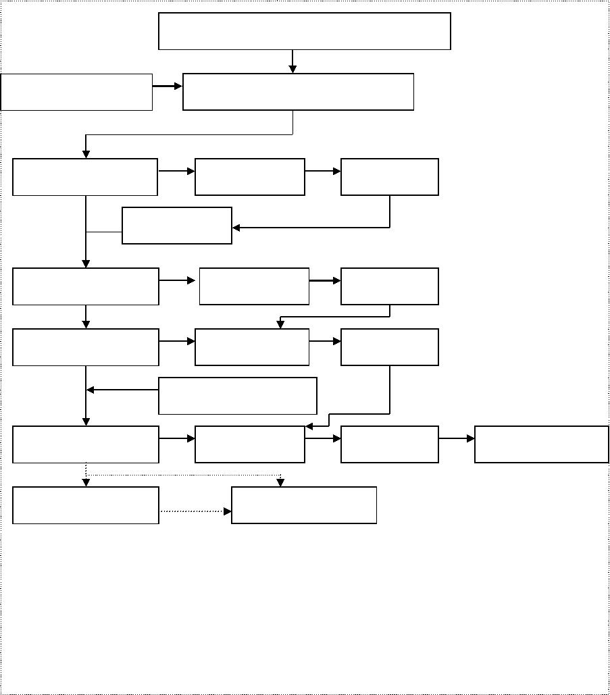

Appendix 2
Validation Matrix
验证表
2.1 HVAC System系统
Item
Description
描述
Quantity
数量
DQ
√
RA
√
FAT
√
SAT
√
Commissioning
IQ
√
OQ
√
Cleaning
PQ
√
No.
1.
GMP Grade AHU
GMP相关空气处理单元
Non GMP Grade AHU
GMP不相关空气处理单元
19
√
√
√
√
2.
20
×
×
√
√
×
×
×
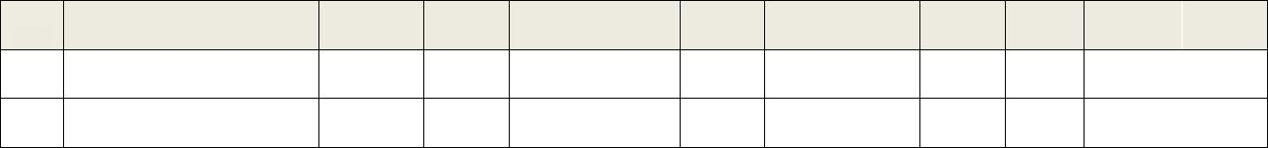
2.2 Controlled Room受控房间
Item
No.
1.
Description
描述
Quantity
数量
1
DQ
√
RA
√
FAT
×
SAT
×
Commissioning
IQ
√
OQ
√
Cleaning
PQ
√
1F Production Area
一层生产区域
√
√
√
√
√
√
√
√
√
√
2.
3.
4.
5.
1F Packaging Area
一层包装区域
1
1
1
1
√
√
×
×
√
√
√
1F Warehouse
一层仓库区域
√
√
×
×
√
√
√
1F Sampling Area
一层取样区域
√
√
×
×
√
√
√
2F Micro Lab
√
√
×
×
√
√
√
二层微生物实验室区域
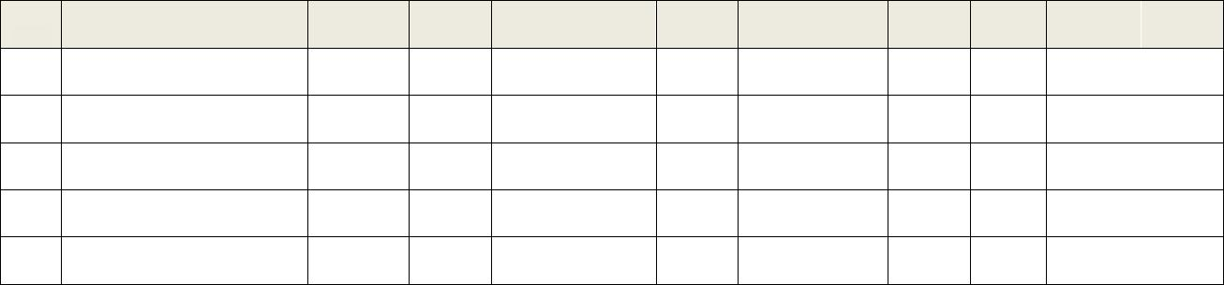
2.3 Utility公用系统
Item
Description
描述
Quantity
数量
1
DQ
√
RA
√
√
×
×
×
×
×
×
×
×
√
×
×
×
×
FAT
√
SAT
√
Commissioning
IQ
√
√
×
×
×
×
×
×
×
×
√
×
×
×
×
OQ
√
Cleaning
PQ
√
√
×
×
×
×
×
×
×
×
×
×
×
×
×
No.
1.
Purified Water System
纯化水系统
√
√
√
√
√
√
√
√
√
√
√
√
√
√
√
√
√
√
√
√
×
×
√
×
×
×
×
√
×
×
2.
3.
4.
5.
6.
7.
8.
9.
Compressed Air System
压缩空气系统
Softend Water System
软水系统
1
1
1
1
1
1
1
1
1
1
1
1
1
1
√
√
√
√
×
√
√
×
Wastewater Treatment System
废水处理系统
Plumbing System
排水系统
×
√
√
×
×
√
√
×
Fire Protection System
防火系统
×
√
√
×
Cabling System
布线系统
×
√
√
×
Fire Alarm System
火警系统
×
√
√
×
Public Address System
广播系统
×
√
√
×
10.
Security System
安保系统
×
√
√
×
11.
12.
13.
14.
15.
EMS
√
√
√
√
环境监控系统
BMS
×
√
√
×
建筑管理系统
Chilled Water System
冷水系统
×
√
√
×
Hot Water System
热水系统
×
√
√
×
Steam & Condensate System
蒸汽和冷凝水系统
×
√
√
×
2.4 Process Equipment工艺设备
Item
No.
Description
Quantity
DQ
RA
FAT
SAT
Commissioning
IQ
OQ
Cleaning
PQ
描述
数量
Unit: Weighing and Dispensing 1称量和分配 1
1.
Downflow Booth
称量罩
1
√
√
√
√
√
√
√
√
√
2.
3.
4.
Bench Scale台秤
2
1
1
√
√
√
√
√
√
×
×
√
×
×
√
×
×
√
√
√
√
√
√
√
√
√
√
×
×
×
Floor Scale地秤
Sieve过筛机
Unit: Material Handling物料转运
5.
IBC
65
1
√
√
√
√
√
√
×
×
√
×
×
√
×
×
√
√
√
√
×
√
√
√
√
√
×
×
√
Unit: Solvent Weighing溶剂称量
Scale秤
Unit: Granulation Train 1湿法制粒线 1
6.
7.
High Shear Granulator
湿法制粒机
1
8.
Fluid Bed Dryer流化床
1
2
5
1
√
√
√
√
√
√
√
√
√
×
√
√
√
×
√
√
√
×
×
√
√
√
√
√
√
√
×
√
√
√
√
√
√
×
×
√
9.
Scale秤
10.
11.
Solution tank溶液罐
CIP在线清洗
Unit: Chilsonator干法造粒
12.
Roller Compactor干压机
Scale秤
1
1
√
√
√
√
√
×
√
×
√
×
√
√
√
√
√
√
√
×
13.
Unit: Milling整粒 1
14.
Co-mil整粒机
1
√
√
√
√
√
√
√
√
√
Unit: Milling整粒 5
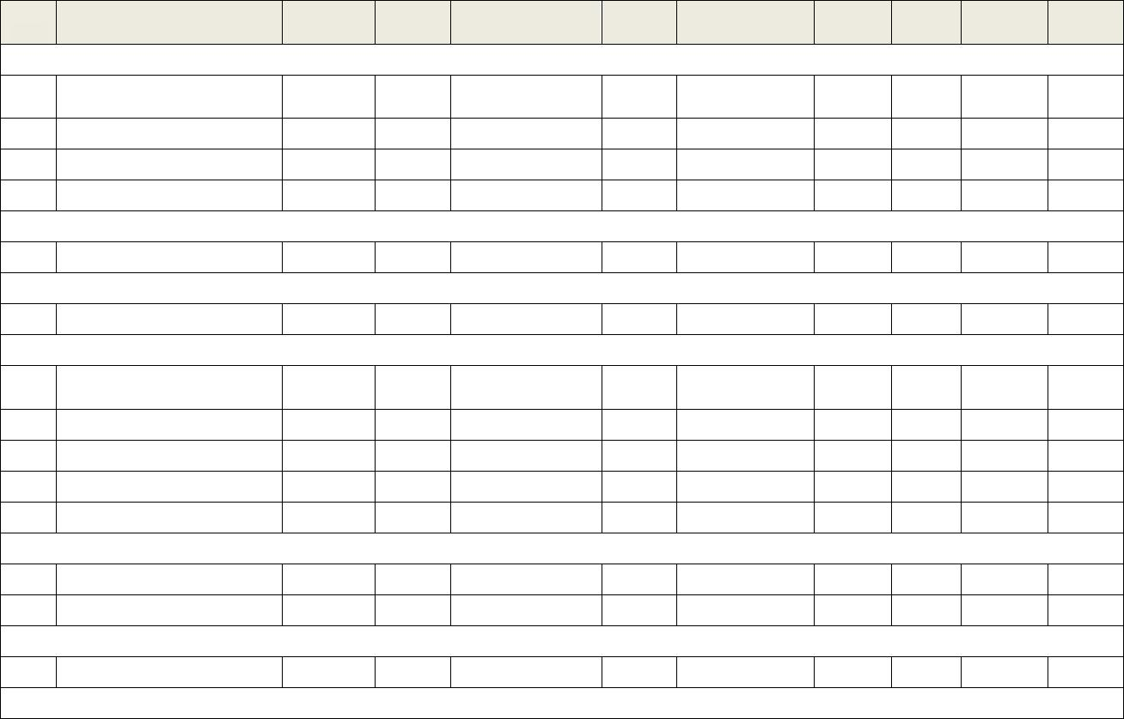
Item
No.
15.
Description
描述
Quantity
数量
1
DQ
RA
FAT
SAT
Commissioning
IQ
OQ
Cleaning
PQ
Sieve过筛机
√
√
√
√
√
√
√
√
√
√
√
√
√
√
√
√
√
√
√
√
√
√
√
√
√
√
√
16.
17.
Mill过筛机
1
1
Mill (for size reduction)
粉碎机
18.
Bin Blender料斗混合机
1
√
√
√
√
√
√
√
√
√
Unit: Bin Blending 1料斗混合 1
19.
20.
Bin Blender料斗混合机
Scale秤
1
1
√
√
√
√
√
×
√
×
√
×
√
√
√
√
√
√
√
×
Unit: Tablet Press 1压片 1
21.
22.
23.
24.
25.
Tablet Press压片机
1
2
2
1
1
√
√
√
√
√
√
√
√
√
√
√
×
×
×
×
√
×
×
×
×
√
√
√
√
×
√
√
√
√
√
√
√
√
√
√
√
√
√
√
√
√
√
√
×
√
Metal Detector金检机
Weight Master检重仪
Scale秤
Hardness/Thickness Tester
硬度/厚度仪
Unit: Tablet Press 2压片 2
26.
27.
28.
29.
30.
Tablet Press压片机
1
1
1
1
1
√
√
√
√
√
√
√
√
√
√
√
×
×
×
×
√
×
×
×
×
√
√
√
√
√
√
√
√
√
√
√
√
√
√
√
√
√
√
√
√
√
√
√
×
√
Metal Detector金检机
Weight Master检重仪
Scale秤
Hardness/Thickness Tester
硬度/厚度仪
Unit: Capsule Filling 1胶囊充填 1
31.
Capsule Filling Machine
1
√
√
√
√
√
√
√
√
√
胶囊充填机
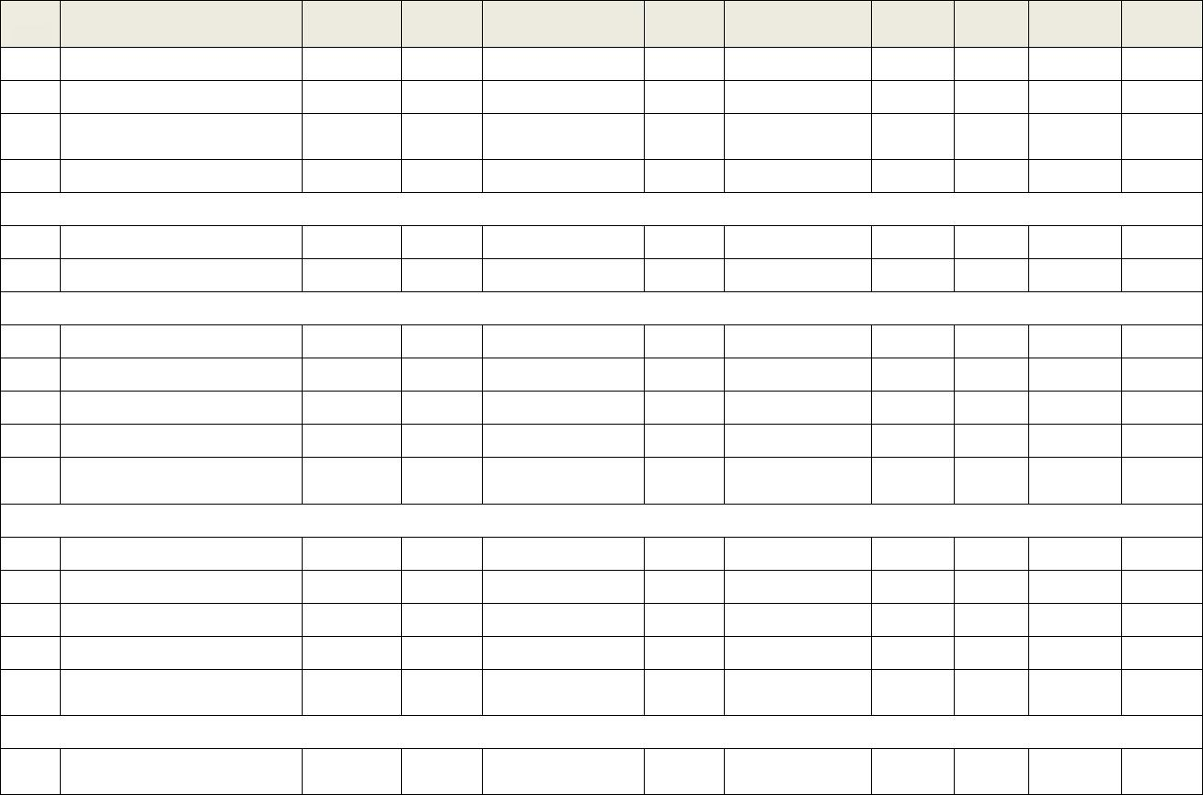
Item
No.
32.
Description
描述
Quantity
数量
1
DQ
RA
FAT
SAT
Commissioning
IQ
OQ
Cleaning
PQ
Capsule Polisher
胶囊抛光机
√
√
√
√
√
√
√
√
√
33.
34.
Metal Detector金检机
1
1
√
√
√
√
×
×
×
×
√
√
√
√
√
√
√
√
√
√
Capsule Checkweigher
胶囊检重仪
35.
Scale秤
1
√
√
×
×
×
√
√
√
×
Unit: Coating 1包衣 1
36.
37.
38.
39.
Coater包衣机
1
1
2
4
√
√
√
√
√
√
√
√
√
×
×
√
√
×
×
√
√
×
×
×
√
√
√
√
√
√
√
×
√
√
√
√
√
×
×
×
Balance天平
Scale秤
Solution tank
溶液罐
40.
CIP 在线清洗
1
√
√
√
√
√
√
√
√
√
Unit: Tablet Belt Inspection 1片剂外观检查 1
41.
42.
Table Checker片剂检查机
Scale秤
1
1
√
√
√
√
×
×
×
×
√
×
√
√
√
√
√
√
√
×
Unit: Tablet Printer 1片剂印字 1
43.
Tablet Printer
1
√
√
√
√
√
√
√
√
√
片剂印字机
Unit: Washing清洗
44.
IBC Washer
1
1
√
√
√
√
√
√
√
√
√
√
√
√
√
√
√
√
√
√
IBC清洗机
45.
Parts Washer
部件清洗机
Dryer干燥器
46.
47.
1
1
√
√
√
√
√
√
√
√
√
√
√
√
√
√
√
√
√
√
Washer洗衣机
Unit: Laundry洗衣
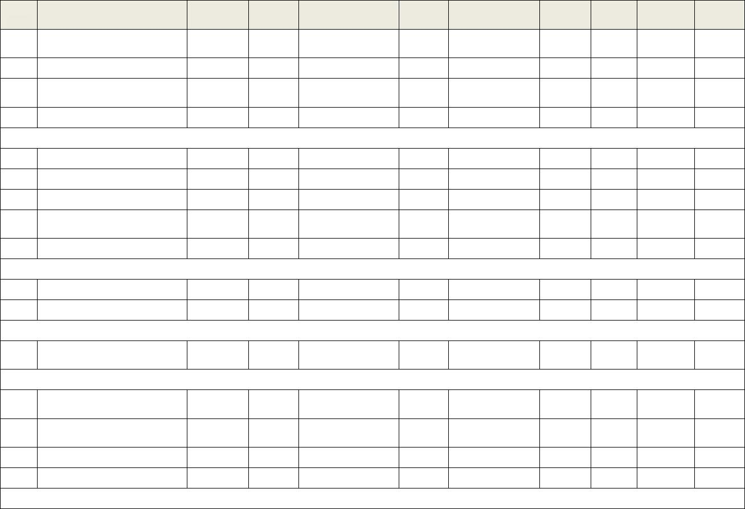
Item
No.
48.
Description
描述
Quantity
数量
2
DQ
RA
FAT
SAT
Commissioning
IQ
OQ
Cleaning
PQ
Washer洗衣机
√
√
√
√
√
√
√
√
√
√
√
√
√
√
√
√
√
√
49.
Dryer干衣机
2
Unit: Blister Packaging 1铝塑包装 1
50.
51.
52.
Metal Detector金检机
Blister铝塑机
1
1
1
√
√
√
√
√
√
×
√
√
×
√
√
√
√
√
√
√
√
√
√
√
√
√
√
√
√
√
Cartoning Machine
装盒机
53.
Check weigher检重机
1
√
√
×
×
√
√
√
√
√
Unit: Bottle Packaging 1瓶包装 1
54.
55.
56.
57.
Unscrambler理瓶机
Blow Maching吹瓶机
Metal Detector金检机
1
1
1
1
√
√
√
√
√
√
√
√
√
√
×
√
√
√
×
√
√
√
√
√
√
√
√
√
√
√
√
√
√
√
√
√
√
√
√
√
Filling&Sealing Machine
装瓶机
58.
59.
Labling Machine贴签机
1
1
√
√
√
√
√
√
√
√
√
√
√
√
√
√
√
√
√
√
Cartoning Machine
装盒机
60.
Checkweigher检重机
1
1
√
√
√
√
×
×
×
×
√
×
√
√
√
√
√
√
√
×
Unit: IPC1中间控制 1
61.
Angle of Repose Tester
休止角检测仪
62.
63.
64.
1
1
1
√
√
√
√
√
√
×
×
×
×
×
×
×
×
×
√
√
√
√
√
√
√
√
√
×
×
×
Balance天平
Density tester密度监测仪
IR-dry(LOD test)
红外水分测定仪
65.
1
√
√
×
×
×
√
√
√
×
Particle Sizer粒径检测仪
Item
No.
66.
Description
描述
Quantity
数量
1
DQ
RA
FAT
SAT
Commissioning
IQ
OQ
Cleaning
PQ
Disintegration Tester
√
√
√
√
√
√
√
√
√
√
×
×
×
×
×
×
×
×
×
×
×
×
×
×
×
√
√
√
√
√
√
√
√
√
√
√
√
√
√
√
×
×
√
√
×
67.
68.
69.
70.
1
1
1
1
Friability Tester脆碎度仪
Hardness Tester硬度仪
Thickness Tester厚度仪
Leak Tester检漏仪
Unit: Material Sampling物料取样
71.
72.
73.
Downflow Booth称量罩
Balance天平
1
1
1
√
√
√
√
√
√
√
×
×
√
×
×
√
×
×
√
√
√
√
√
√
√
√
√
√
×
×
Scale秤
Unit: Pilot中试
74.
75.
76.
77.
Downflow Booth称量罩
1
2
4
1
√
√
√
√
√
√
√
√
√
×
×
√
√
×
×
√
√
×
×
√
√
√
√
√
√
√
√
√
√
√
√
√
√
×
×
P
Balance天平
Scale台秤
High Shear Granulator
湿法制粒机
78.
Fluid Bed Dryer
流化床
1
√
√
√
√
√
√
√
√
√
79.
80.
Solution tank溶液罐
2
1
√
√
√
√
√
√
√
√
×
√
√
√
×
√
√
√
×
√
WIP for HSM/FBD
制粒在线清洗
81.
82.
83.
84.
85.
Co-mill干/湿整粒机
1
1
1
2
1
√
√
√
√
√
√
√
√
√
√
√
√
√
×
×
√
√
√
×
×
√
√
√
√
√
√
√
√
√
√
√
√
√
√
√
√
√
√
√
√
√
√
√
√
√
Bin Blender混合机
Tablet Press压片机
Metal Detector金检机
Hardness/Thickness Tester
硬度/厚度仪
Item
No.
86.
Description
描述
Quantity
数量
1
DQ
RA
FAT
SAT
Commissioning
IQ
OQ
Cleaning
PQ
Tablet Weight Master
片剂检重仪
√
√
×
×
√
√
√
√
√
87.
88.
Capsule Filler胶囊充填机
1
1
√
√
√
√
√
√
√
√
√
√
√
√
√
√
√
√
√
√
Capsule Polisher
胶囊抛光机
89.
Capsule Checkweigher
胶囊检重仪
1
√
√
×
√
√
√
√
√
√
90.
91.
Coater包衣机
1
1
√
√
√
√
√
√
√
√
√
√
√
√
√
√
√
√
√
√
WIP for Coater
包衣机在线清洗
Bottle Packaging Line
瓶包装线
92.
1
√
√
√
√
√
√
√
√
√
93.
94.
Label Machine贴标机
1
1
√
√
√
√
√
√
√
√
√
√
√
√
√
√
√
√
√
√
Dryer干燥器
Unit: Solvent Sampling溶剂取样
95.
96.
Downflow Booth称量罩
Scale秤
1
1
√
√
√
√
√
×
√
×
√
×
√
√
√
√
√
√
√
×

Appendix 3
Overview of SIA process flow diagram:
总结系统影响性评估流程
System Definition
Develop System
Boundaries
Yes
Does the system
have direct impact
on products?*
No
Yes
Is the system
linked to a direct
impact system?
Indirect Impact
System
Direct Impact
System
No
No Impact
System
Develop Supporting
Rationale
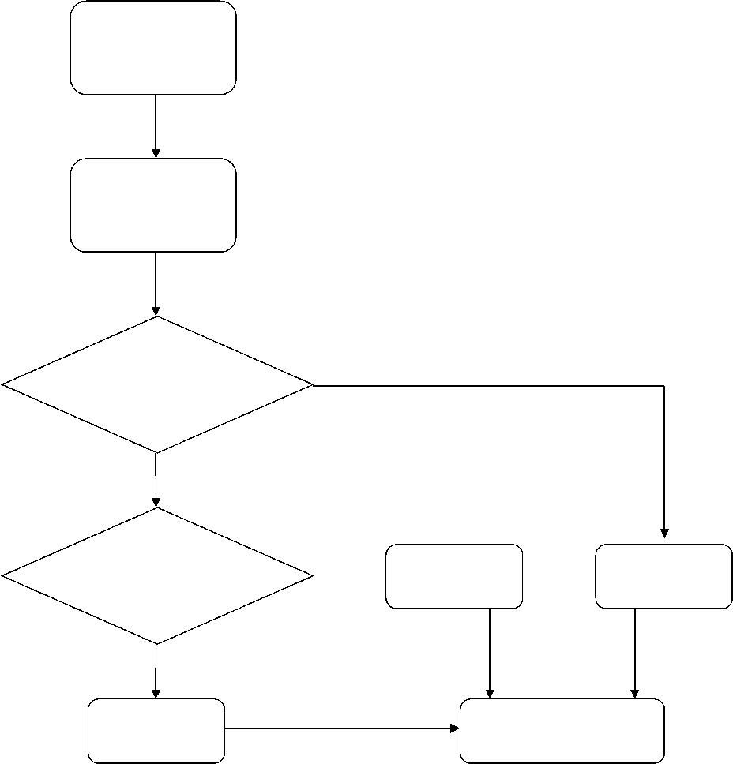

Appendix 4
Qualification / Validation Time Schedule
确认/验证时间进度表
System Description
系统描述
Item
No.
2013-04
2013-05
2013-06
2013-07
……
1.
HVAC
2.
Environmental room
受控房间
3.
4.
Utility
公用设施
Process Equipment
工艺设备
Remark:
1. Herein the general schedule for qualification / validation with .
这里是一个确认/验证的简略时间表，用阴影表示。
2. A detailed qualification / validation schedule will be prepared and weekly updated by project scheduler when qualification / validation activities begin.
一个详细的确认/验证时间表应准备，并在确认/验证开始后，由项目进度控制人员每周更新。
3. The final version of qualification / validation schedule will be served as Appendix 3 of this VMP.
最终版本的确认/验证时间表将和本验证主计划中附件 4一致。

Appendix 5
Documentation Support for Qualification
支持确认的文件
Documentation Description
Design Qualification
User requirement specification (URS)
Cleanliness Zone concept plan
Process overview(PFD, P&ID, arrangement drawing, include Component list)
Functional specification
Equipment specification
Instrument list with specification
Electrical specification(Wiring diagram)
Process automation hardware design specification
Process automation software design specification
Supplier assessment/audit
ERES classification report
Definition of critical functions and parameters (Matrix)
Documentation list (baseline)
GMP compliance review report
Installation Qualification
Cleanliness zone concept plan with “As-built” status
Process overview document with “As-built” status
Filter list
Instrument list with “As-built” status
Calibration record (procedure, protocol, certificates)
List identifying product contact material
Welding documentation
Check for completeness include tagging and labeling
Tightness test report (pressure and/or vacuum) for equipment piping
Drain ability test report (with slope and low points verified)
Initial cleaning and flushing documentation (procedure, protocol)
Documentation Description
Wiring diagram with “As-built” status
Process automation hardware test
Process automation software integration test
Process automation application program documentation (include inventory)
ERES conformity report
Supplier start-up and operating instructions
Supplier maintenance instructions and spare part list
Equipment logbook (include inventory)
Operational Qualification
Completed calibration record (procedure, protocol, certificates)
Test procedures for testing critical functions
SOP: system operating (at least as a draft)
SOP: cleaning/sanitization (at least as a draft)
SOP: calibration (at least as a draft)
SOP: Preventive Maintenance (at least as a draft)
SOP: Training (Operators, at least as a draft)
SOP: Backup & Security (at least as a draft)
Completed training record
Performance Qualification
Test procedure for testing of critical parameters
SOP: system operating (approved)
SOP: cleaning/sanitization (approved)
SOP: calibration (approved)
SOP: Preventive Maintenance (approved)
SOP: Training (Operators, approved)
SOP: Backup & Security (approved)
Remark:
Herein is the normal requirement for qualification and specific system might have specific requirement.
这里是确认的通常要求，而特殊系统可能有特殊要求。

